Institution: Majmaah University
College: Computer and Information Sciences
Department: Information Technology
Program: Master in Cybersecurity and Digital Forensics
Report Date: 22 January 2024
Contact Information:
Name: Dr. Fahad Alodhyani
Position: Department Head
Email: f.alodhyani@mu.edu.sa
Mobile: +966503200955

Table of Contents
Self-Study Report Preparation Guidelines: 3
Executive Summary: 4
1. Program Profile 6
1.1 Program Mission 6
1.2 Program Goals 6
1.3 A List of the Program Achievements, Awards, and Significant Accomplishments 6
1.4 Total Credit Hours: 6
1.5 Major Tracks/Pathways _{(if any)} 6
1.6 Intermediate Exit Points/Awarded Degree _{(if any)} 6
1.7 Branches Offering the Program 6
1.8 Program Statistical Data 7
2. program Self-Study 9
2.1 Benchmarking partners and selection criteria/reasons (internal and exteranal) 9
2.2 Summary of KPIs and Benchmarks 10
3. Evaluation in Relation to Quality Standards 12
Standard 1. Program Management and Quality Assurance 12
Standard 2. Teaching and Learning 17
Standard 3. Students 24
Standard 4. Faculty 29
Standard 5. Learning Resources, Facilities, and Equipment 31
Standard 6. Research and Projects 33
4. Independent Evaluations (Optional) 36
5. Action Recommendations 36
6. Attachments 36

Self-Study Report preparation guidelines:
The report aims primarily to support the development of the Program’s performance. In order to achieve this purpose, the following points should be taken into account:
- The accuracy and credibility of the data and information are maintained throughout the report.
- Evaluation results of the indicators are provided with supporting evidence.
- Informal, vague, exaggerated, or subjective expressions are avoided, as well as those that are generally unnecessary or incorrect.
- Only relevant evidence and data that lead to informed conclusions are presented.
- Evaluation results are correlated with improvement priorities.
- elaboration on general description should be avoided. The focus should be directed to the main aspects.
- Perceptive comments should be essentially made on criteria that are rated less than 3 or above 4.
- All evidence and proofs on which the self-study was based should be attached and uploaded to the Academic Accreditation Portal on the NCAAA-ETEC website.
- Do not attach files (photos, messages, emails, notes, questionnaires, memos) to the self-study report. These may be made available for consultation during the Program’s Review Visit.

Executive summary:
This should include the overall result of the evaluation of each Standard, the most visible strengths, and the most significant improvements at the program level along with the operational recommendations.
Overall Evaluation in Relation to Quality Standards:
No. | Standard | Overall Evaluation
 | Program Management and Quality Assurance | 4
 | Teaching and Learning | 4
 | Students | 4
 | Teaching Staff | 4
 | Learning Resources, Facilities, and Equipment | 4
 | Research and Projects | 4

Strengths:
- Quality Assurance manual is available for faculty
- Evaluation and planning for quality improvement are integrated into administrative processes. Staffs participate in self-assessment and reporting through course reports and different committees with assigned tasks.
- The intended learning outcomes are consistent with requirements for professional practice in Saudi Arabia.
- The institutional environment is conducive for learning.
- The Student community has positive attitude and are cooperative which is helping them to attain better results
- Student faculty ratio is adequate.
- Rate of published research per faculty member is satisfactory
- Classrooms and computer labs equipped with various means and facilities on the process of teaching and learning facilities are adequate for the time being.
- There are enough computers for all faculty members. Computers available for students are sufficient for the time being to enable them to study and perform exercises.
Areas and priorities for Improvement:
- Strengthen the Quality Assurance and Management Plan implementation process for consistency of quality assurance practices and monitoring of KPIs for continuous improvements.
- Proper and timely feedback of analysis results needs to be provided to planners (teaching staff, course conveners and HODs) to ensure quality improvement.
- Strengthen the Quality Assurance and Management Plan implementation process for consistency of quality assurance practices and monitoring of KPIs for continuous improvements.
- Increase in more SCI/SCIE indexed publications
- Develop periodic maintenance plan for all devices to ensure the continuity of their work satisfactorily.
- Emergency evacuation training to be given to faculty and students.
- The library does not have references to program's courses.
- Increase in the Percentage of Students' Publication
Action recommendations:
- Provide feedback to the program management on improvement plan based on PLO assessment and KPI scores
- PLOs assessment results should be analyzed for not achieving less than 70%
- Introduce more exercises and give them small projects to make all the students to reach the level EE
- Concentrating on funded projects (Internal & External)
- Develop a plan for emergency evacuation in the event of natural disasters.
- Request purchasing of enough copies for courses' essential references.

1. Program Profile

1.1 Program Mission
Prepare qualified national graduates with high skills and enough experience to join and engage into labor market of the different fields of Information Technology by providing the graduates with the latest knowledge, advanced skills, and strong moral values to serve the kingdom of Saudi Arabia.

1.2 Program Goals
The program aims to produce graduates who can:

PEO1: Practice as computing professionals in areas of IT with an appropriate combination of theoretical knowledge and hands-on skills.

PEO2: Enhance their skills and master new computing technologies through self-directed professional development or post-graduate education.

PEO3: Follow a career path toward leading positions in the IT field.

1.3 A List of the Program Achievements, Awards, and Significant Accomplishments

1.4 Total Credit Hours: | ( 30 )

1.5 Major Tracks/Pathways _{(if any)}
Major Tracks/Pathways | Credit Hours  (For each track)
- NA

1.6 Intermediate Exit Points/Awarded Degree _{(if any)}
Intermediate Exit Points/Awarded Degree | Credit Hours
- NA

1.7 Branches Offering the Program
- Main Campus

31.8 Program Statistical Data
1.8.1 Students Enrolment
Number of Students |  | Two Years Ago | Last Year | Current Year | Expected  Next Year
Proposed Number of Enrolled Students | Male | 25 | 25 | 25 | 25
 | Female | 25 | 25 | 25 | 25
 | Total | 50 | 50 | 50 | 50
Total number of Enrolled Students | Male | 17 | 31 | 36 | 41
 | Female | 10 | 17 | 16 | 35
 | Total | 27 | 48 | 52 | 76
Number of Enrolled International Students | Male | 0 | 0 | 0 | 0
 | Female | 0 | 0 | 0 | 0
 | Total | 0 | 0 | 0 | 0
Average Class Size | Male | 17 | 19 | 20 | 25
 | Female | 10 | 9 | 10 | 25
 | Total | 27 | 28 | 30 | 50
Ratio of Students to Teaching Staff | Male | 1.7 | 3.1 | 3.6 | 4.1
 | Female | 1.0 | 1.7 | 1.6 | 3.5
 | Total | 2.7 | 4.8 | 5.2 | 7.6
*Insert a separate table for the main location and for each branch.

1.8.2 Classification of Students Based on Mode of Study _{(For Current year)}
Classification |  | Number of Students
 |  | Saudi |  |  | Non-Saudi |  |  | Total
 |  | Male | Female | Total | Male | Female | Total
Mode of Study | On Campus | 36 | 16 | 52 | 0 | 0 | 0 | 52
 | Distance Education | 0 | 0 | 0 | 0 | 0 | 0 | 0

1.8.3 Graduation Rate
Graduates | Three Years Ago | Two Years Ago | Last Year
Number of Graduates
Male | 9 | - | 9
Female | 9 | - | 8
Total | 18 | - | 17
Graduates’ Employment
Number of Employed Graduates | 9 | - | 10
Ratio of Employed to Total Graduates | 50% | - | 58.8%

1.8.4 Number of Teaching Staff
Teaching Staff |  | Saudi |  |  | Non-Saudi |  |  | Average Teaching Load For All Teaching Staff
 |  | Male | Female | Total | Male | Female | Total | Male | Female | Total
No. of  Ph.D. Holders | Professor | 1 | 0 | 1 | 1 | 0 | 1 | 3 | 0 | 3
 | Associate Prof. | 0 | 0 | 0 | 3 | 1 | 4 | 3 | 3 | 3
 | Assistant Prof. | 3 | 0 | 3 | 1 | 0 | 1 | 3 | 3 | 3
 | Total | 4 | 0 | 4 | 5 | 1 | 6 | 3 | 3 | 3
*Insert a separate table for the main campus and each branch.
**Attach a detailed list for teaching staff including the following (name, gender, nationality, degree, mode of study (on-campus, distance education), academic rank, general and specific specialty, institution graduated from, and list of current courses taught in the current academic year).

1.8.5 Classification of Teaching Staff According to Mode of Study
Teaching Staff | On-Campus |  |  | Distance Education
 | Full-time | Part-time |  | Full-time | Part-time
 |  | Number | FTE  (full-time equivalent) |  | Number | FTE  (full-time equivalent)
Male | 9 | 0 | 0 | 0 | 0 | 0
Female | 1 | 0 | 0 | 0 | 0 | 0
Total | 10 | 0 | 0 | 0 | 0 | 0

1.8.6 Overall Assessment of Program Statistical Data:
Strengths:
- Student faculty ratio is adequate.
- High success rate.
- High retention rate for faculty and students.
Areas and priorities for Improvement:
- More attention is required towards number of foreign students in the program.
Action recommendations:
- Attracting more foreign students to the program.
- Inviting esteemed faculty members from highly renowned universities to offer some of the courses.

2. Program Self-Study

2.1 Benchmarking partners and selection criteria/reasons (internal/external)
No. | Benchmarking partners | Selection criteria/reasons

2.2 Summary of KPIs and Benchmarks
A list of the KPIs that are used (including NCAAA required KPIs).
KPI  No. | KPI | KPI Results
 |  | Actual | Target Benchmark | Internal Benchmark | External Benchmark
KPI-PG-1 | Students' Evaluation of Quality of learning experience in the Program | 4.1 | 4.5 | - | -
KPI- PG-2 | Students' evaluation of the quality of the courses | 4.4 | 4.5 | - | -
KPI-PG-3 | Students' evaluation of the quality of academic supervision | 100% | 80% | - | -
KPI-PG-4 | Average time for  students’ graduation | 2 years | 2 years | - | -
KPI-PG-5 | Rate of students dropping out of the program | 21%  (In First Semester) | 10% | - | -
KPI-PG-6 | Employers' evaluation of the program graduates’ competency | Not Measured | 4 | - | -
KPI-PG-7 | Students' satisfaction with services provided | 60% | 90% | - | -
KPI-PG-8 | Ratio of students to faculty members | 5:1 | 6:1 | - | -
KPI-PG-9 | Percentage of publications of faculty members | 100% | 60% | - | -
KPI-PG-10 | Rate of published research per faculty member | 5 | 1 | - | -
KPI-PG-11 | Citations rate in refereed journals per faculty member | 3.01 | 1 | - | -
KPI-PG-12 | Percentage of students' publication | 75% | 100% | - | -
KPI-PG-13 | Number of patents, innovative products, and awards of excellence | - | - | - | -

Important Note:
Provide description and analysis for each KPI under the related Standard with a trend.

3. Evaluation in Relation to Quality Standards

Standard 1. Program Management and Quality Assurance
The program must have effective leadership that implements the institutional systems, policies and regulations. The program leadership must plan, implement, monitor, and activate quality assurance systems that achieve continuous development of program performance in a framework of integrity, transparency, fairness and within a supportive organizational climate.
Levels of Evaluation  Elements of Evaluation |  | NA | Not Satisfactory |  | Satisfactory
 |  |  | Non-Compliance | Minimal Compliance | Substantial Compliance | Full Compliance
 |  |  | 1 | 2 | 3 | 4
1-1 | Program Management
1-1-1 | The program mission and its goals are consistent with the mission of the institution/college, and guide all its operations and activities. |  |  |  |  | P
1-1-2 | The program has the sufficient number of qualified staff to perform its administrative, professional and technical tasks, with defined tasks and authorities. * |  |  |  |  | P
1-1-3 | The program provides an organizational climate and supportive academic environment. |  |  |  |  | P
1-1-4 | The program management monitors the achievement of its goals and actions that are taken for improvement. |  |  |  | P
1-1-5 | The program management applies mechanisms ensuring integrity, fairness, and equality in all its academic and administrative practices, and between the male and female student sections and branches (if any). |  |  |  |  | P
1-1-6 | The program builds on the views of professionals and experts in the program specialization, to contribute to its evaluation, development, and performance improvement. |  |  |  |  | P
1-1-7 | The program management provides reliable and publicly disclosed information to the community about the program description, performance, and achievements that suits the needs of the stakeholders. |  |  |  |  | P
1-1-8 | The program management is committed to activating the values of the scientific integrity, intellectual property rights, rules of ethical practices, and proper conduct in all academic, research, administrative, and service fields and activities. * |  |  |  |  | P
1-1-9 | The program management applies the systems, regulations, and procedures that are approved by the institution/college, including those related to grievance, complaints, and disciplinary cases. |  |  |  | P
1-2 | Program Quality Assurance
1-2-1 | The program management implements an effective quality assurance and management system that is consistent with the institution quality system. |  |  |  |  | P
1-2-2 | The program analyzes the key performance indicators and the evaluation data annually and its results to be used in planning, development, and decision-making processes. * |  |  |  |  | P
1-2-3 | The program conducts a periodic, comprehensive evaluation and prepares plans for improvement; and follows up its implementation. |  |  |  | P
Overall Evaluation of the Standard
Total Sum of Evaluation of Criteria  (Total Sum of Points) |  | 45
Number of Applicable Criteria |  | 12
Average Evaluation of the Standard |  | 3.75
Overall Quality Rating of the Standard |  | 4
* Essential Criteria

Comments on Results:
Provide an analytical and evaluation report in this section about the results of each standard based on required data, evidence, and related KPIs. (Please link the analysis with the PLOs assessment contained in the Program Report for the last two years in addition to discussing the program's performance on each criterion).
  - Program Management

Introduction
The Department of Information Technology in the College of Computer and Information Science (CCIS) at Majmaah University (MU) offers a MS degree in Cybersecurity and Digital Forensics (CSDF) that is cross-disciplinary and includes technology, management, compliance, and legal issues available in the Kingdom of Saudi Arabia.

Foundations Digital Forensics
Computer forensics is the scientific examination and analysis of data held on, or retrieved from, computer storage media in such a way that the information can be used as evidence in a court of law.

Foundations of Cyber security
Cyber security is the body of technologies, processes and practices designed to protect networks, computers, programs and data from attack, damage, or unauthorized access.

Program details

Program title | MS in Cybersecurity and Digital Forensics
Title abbreviation | MS in CSDF
Program type | Master's Degree by Coursework and Research Project
Status | Proposed to open 1st Semester 2018-2019
Administered by | College of Computer and Information Sciences
Intake periods | First semester
Attendance type | Full-time
Credit hours required | 30 credit hours
Standard program duration | 2 years full-time
Maximum Time Limit | 4 years
Delivery mode | In-class
Locations | Main Campus, Majmaah University
Language of instruction | English
Pre-Requisites | BS or BSc degree in Computing domain, such as CS, IT, IS, CE, or a related field (degree in other field is accepted only if candidate has either previous work experience or in-service training in IT, with )
Program Coordinator(s) | Dean of CCIS
Contact details for program information | Department of Information Technology, College of Computer and Information Science
Program Overview
Computers are central to all aspects of our daily lives; as industries ranging from communications to banking have come to rely on them, the need for improved computer security has never been greater. This Program focuses on two aspects, Cybersecurity and Digital Forensics.
Students joining the Program will gain an understanding of the nature of the security threats that face computer systems and the type of information that is stored on digital devices (and how it can be extracted from them). They will benefit from a broad and varied array of state-of-the-art tools and technologies.

In the MS in Cybersecurity and digital forensics at CCIS, MU student gains the capability to help organizations and law enforcement detect data breaches, cyber-attacks, and digital crime. Learn how to determine whether a digital system has been attacked or compromised as well as how to uncover, preserve, and present evidence for legal prosecution.

Coursework in the Cybersecurity and digital forensics master's degree can help student gain the technical competencies and knowledge needed to investigate system security breaches and recover lost or compromised data. Our curriculum features hands-on learning experiences that use the same evidence and scenarios encountered in real-world investigations.

Program Description
The Master’s degree of Cybersecurity and Digital Forensics (CSDF) is a postgraduate award offered by the CCIS at Majmaah University. It is designed for postgraduate scholars and professional managers with appropriate undergraduate qualifications in IT, computer science, electrical, computer or systems engineering or a related discipline and/or extensive relevant professional experience who wish to gain a more detailed understanding of the technical skills and expertise relevant to the technical implementation and leadership of the Cybersecurity and Digital Forensics function.
The MS in CSDF program offers a balance of practice and theory through study in Information Technology, law and criminal justice. The goal is to produce professionals qualified as digital forensic scientists who can apply and sustain their expertise as new technological and societal challenges emerge, who understand the scientific, legal and criminal justice context of high technology crime, and who can effectively communicate their knowledge to others.

College Mission Statement
The mission of the College of Computer & Information Sciences is to provide distinguished educational programs based on latest developments in computer and

and to develop highly scientific and academic qualified graduates ,information sciences
.and successful competitors in the labor market to contribute to the national development

Department Mission Statement
Prepare qualified national graduates with high skills and enough experience to join and engage into labor market of the different fields of Information Technology by providing and strong moral values to serve the kingdom of Saudi Arabia
The program is headed by the Head, Dept. of IT and supported by Dean and Vice-Deans of College of Computer and Information Sciences. All the policies related to the program are approved by the College Council and the University Council. The program curriculum is well prepared as per the international standards with the following Program Educational Objectives:

Program Educational Objectives

- Practice as computing professionals in areas of Cybersecurity and Digital Forensics with an appropriate combination of theoretical knowledge and hands-on skills.

- Enhance their skills in wide aspects of the security of information systems and specialized skills in computer security incidents and crime evidence and master new computing technologies through self-directed professional development or conduct research in Cybersecurity and Digital Forensics field.

- Follow a career path toward leading positions in the Cybersecurity and Digital Forensics field.

Needs for the MS in Cybersecurity and Digital Forensics (CSDF) program degree in KSA:
As Cybercrime continues to escalate, corporations, government agencies and organizations are seeking Cybersecurity experts to develop innovative tools and techniques to safeguard information, information systems and infrastructures, and to respond to computer security breaches and attack.
The need for Cybersecurity experts spans all industries, from financial services, manufacturing and utilities to healthcare and retail.
Cybersecurity jobs also are plentiful in the KSA government market. The Statistics predicts that careers in Cybersecurity and digital forensics will grow at a faster pace in comparison to other professions.

Some of Careers in this field include:

Information Security Crime Investigator/Forensics Expert
- System, Network, and/or Web Penetration Tester
- Security Architect / Security Analyst
- Application Penetration Tester and Incident Responder
- Software / Application Development Security
- Disaster Recovery/Business Continuity Analyst/Manager

Program Contents
All students will take the modules which are designed to give a comprehensive introduction to this specialist field. They will cover basic digital forensics and security. Dealing with digital evidence in a professional manner (that includes adhering to appropriate legal guidelines) is also covered.

The course offers the opportunity to examine a variety of tools available on the open market, and the use of forensic tools to retrieve data from electronic sources. It will also consider the analysis of professional and ethical issues relating to computer security and forensics, and the development of professional competencies, such as report writing and presenting evidence in court.

Curriculum
The program adopts a practical approach, which sees students undertake a research project and get many hands-on labs experience. The curriculum primarily covers key areas from Cybersecurity and Digital Forensics domains, such as (but not limited to)

Cybersecurity
- Information & Network Security
- Web, Software, Mobile, Hardware, Data, People, etc. Security
- Cybersecurity Governance & Management

- Cybercrime & Response
- Cyber Law, Compliance & Ethics
- Ethical Hacking and Penetration Testing

Digital forensics
- File Systems, Disks, Devices, Data, Hardware, OS, etc. Forensics
- Network and Mobile Forensics
- Forensic data analysis and Investigation
- Evidence collection, processing, analysing, and reporting
- Malware development and countermeasures

The MS in CSDF degree is comprised of 30 credits hours of graduate study which include 15 credits core courses, six credits from Cybersecurity or related domains, six credits from digital forensics or related domains, and three credits Research Project.

STUDY REGULATIONS AND TESTS
Student Performance

At the masters level, a programme coordinator manages the program and also allocates academic advisors. After assigning an academic advisor for each student in the program, the student is required to meet his/her academic advisor for the purpose of registration based on his/her study plan, addressing any academic or career issues, and meeting graduation requirements. Each student has his/her own study plan based on the progress in his/her academic study and his/ her choice of the program's tracks. The student is required to maintain an updated study plan each semester to help him/her in choosing appropriate courses for registration in the following semester and to easily follow up the academic progress. The study plan is available for both students and academic advisors^{[1]}.

At th master's level, the student should obtain atleast a B grade (8.0) in each course to be considered pass in that course. The performance of the student in his/her courses is evaluated by the instructor using course assessment tools such as final exams, midterms, quizzes, homework, projects, reports etc. that fulfill the course/student outcomes. The instructors are invited to submit list of students who suffer difficulties in their classes to academic advisors. This will help the advisors to present assistance to those students in order to improve their performance in the class. In addition, students are encouraged to stop by their instructor's office during the office hours to discuss with them any concerns regarding the course.

Grade Distribution
The full mark for every course is 100, which is typically distributed as follows:
20 Marks for Midterm Exam
40 Marks for Final Exam that covers the entire course contents.
40 Marks for Semester work such as: verbal and written tests, reports or research work or additional studies, experimental lab, and weekly or monthly homework.

Instructors could alter this distribution given that the grade of the Final Exam does not exceed 60% of the total course grade, in addition to at least one midterm exam for no less than 20% of the total course grade.

Examination
The overall marks of any course is calculated as following
- Sixty (60) marks out of one hundred (100) for student work during the semester that includes at least one written midterm and one or more of the following choices
- Written midterm
- Quizzes
- Oral exams
- Projects
- Presentations
- Class Activities
- Laboratory work
- Research
- Forty (40) marks for the final examination that designated during the last week of each semester of the academic year.

Table 1.5 shows the grading system used at Majmaah University. The table shows that each letter grade has a numeric value represented by points. The points of each course are based on this number value and the credit hour value of that course. The following table shows the letter grades and their related points, course grade, and mark.

Table 1.5: Grading System at Majmaah University
Grade | Points | Course Grade | Mark
A+ | 5.00 | Excellent Plus | 95 – 100
A | 4.75 | Excellent | 90 less than 95
B+ | 4.50 | Very Good Plus | 85 less than 90
B | 4.00 | Very Good | 80 less than 85
C+ | 3.50 | Good Plus | 75 less than 80
C | 3.00 | Good | 70 less than 75
D+ | 2.50 | Pass Plus | 65 less than 70
D | 2.00 | Pass | 60 less than 65
F | 0.00 | Fail | Less than 60
IC |  | Incomplete
IP |  | In process
W |  | Withdrawal
DN | 1.00 | Deprivation

Courses with a grade of IC, IP, and W carry no grade value. The grade of incomplete (IC) initially carries no grade value for courses that require more than one semester. The Department Council responsible for that course may allow the student to complete the requirements of any course in the following semester on the basis of a recommendation by the instructor of the course. The student then receives (IC) grade in his/her academic record and it is not calculated in his/her semester average nor in his/her accumulative average unless he/she fulfills the requirements of that course. If one academic semester passes without changing the (IC) grade in the student’s record due to not fulfilling the course, the (IC) grade is replaced by (F) which is calculated in his/her semester average and in his/her accumulative average.

The grade of In Process (IP) initially carries no grade value for research courses that require more than one semester. The student then receives (IP) grade in his academic record and it is not calculated in his semester average or in his accumulative average. If the requirement of that course is not finished within the proposed period, the Department Council which is responsible for that course may replace (IP) grade by (IC) grade.

The deprivation (DN) grade, resulted from more than 25% absence rate in a course, carries a “1” points and included in the accumulative average.

Semester and Accumulative Average
Semester GPA (or GPA in short) is resulted by dividing the sum of the points obtained by the student in all courses he/she studied during any individual semester by the total number of credit hours of those courses.

Accumulative GPA (or AGPA) is resulted of dividing the sum of points obtained by the student in all the courses that he/she has studied during his study in all semesters by the number of units representing those courses.

The following conditions must be met for a student to be granted honors:
- The student should not fail in any course taken at Majmaah University or any other university.
- The student must fulfill the graduation requirements within the standard period for his/her program
- The student must study all the assigned courses and should have completed the Dissertation / Term Project successfully.

Attendance
Absences are counted from the first day of the semester. The student must regularly attend all lectures and practical lessons. The student will not be allowed to participate in the final examinations if his/her percentage of attendance is less than (75%) of the lectures and practical lessons allotted for the course.
The student who is deprived of attending the final examination will fail that course and have grade DN, unless he/she provides an excuse accepted by the College Council under the condition that he/she was not less than 50% of attendance.

Probation
The student is required to maintain a AGPA of at least 4.0 out of 5.0. The student will receive an academic warning if his/her accumulative average is less than (2.00). Those who fail to maintain this AGPA will be placed on scholastic probation and are given two semesters in which they must improve their AGPA to at least 2.0. If this condition is not met and the student received three consecutive warnings (two semesters of probation), the student may then be dismissed from his/her study program.

Handling Prerequisites
Under normal circumstances, all students are registered automatically through the university registration system, EduGate. Each student is automatically enrolled in all level courses he/she is allowed to register for. The system may allow the student to make changes to his/her registration under the condition that no violations to any of the prerequisites, no conflicts between courses timetables, and the student does not exceed the allowed number of credit load per semester. This process is handled automatically through the university’s registration system without any manual interference.

The student is allowed to make changes to his/her schedule by either adding or dropping courses only for up to the end of the first week of study. Course withdrawals, however, are allowed before the end of the tenth week of study of the semester. A student is allowed to withdraw for only one course per semester under the condition that he/she does not withdraw for more than three courses during his/her full study plan. A student can also withdraw the whole semester, usually no later than the end of the twelfth week of study pending department head and vice-dean for academic affairs approvals.

Work in Lieu of Courses

The program only grants credit(s) for the academic courses that are successfully completed. No credit is offered towards achieving life experience, Advanced Placement, dual enrollment, or military experience.
Visiting Students
A visiting student is he who studies some courses in another university or a branch of thesame university without transferring to it. The courses he studies are equated according tothe following regulations:
a. The student has to get the approval of the college in which he intends to study as avisiting student prior to admission.
b. The college or the university in which he intends to study should be a recognizedinstitution.
c. The courses to be studied in another university should be equivalent to therequirements of graduation in his university.
d. If the visiting student studies in one of the branches of the college he studies in, hewill be treated in accordance with Article (47).
e. The University Council determines the maximum percentage of credit hours to beconsidered for the external student.
f. The courses equated for the visiting student are not counted within his CGPA. Thecourses are written on his academic record.
g. Any other conditions set by the University Council.
The Operational Rule for Majmmah University
A visiting student is the student who studies some courses in another university or abranch of the same university without transferring to it. The courses he studies areequated according to the following regulations:Firstly, any student from Majmaah University who wants to study as a visitingstudent:
1. Bring a prior permission from his college allowing him to study as a visiting student,determining the courses he would like to study. The college may condition that thestudent should attain a specific rate for the course equation. He will be given a letterfrom the Deanship of Admission and Registration to that effect.

2. The student should have an academic record with a (CGPA) for at least one semesterin the university, before he applies as a visiting student.
3. The university or the college in which he intends to study should be a recognizedinstitution.
4. The course the student intends to study in another university should be equivalent toone of the courses included as part graduation requirements.
5. Taking into account (Article 42), the maximum total for the credit hours to be countedfor a visiting student is 20% from the total graduation credit hours in MajmmahUniversity.
6. Equated courses of the visiting student shall not be counted as part of the student's(CGPA). The courses shall, however, be registered in his academic record.
7. The student should inform the Deanship of Admissions and Registration the results heobtains within the first week from the beginning of the semester following his study asa visiting student. If he does not provide his results , he shall be considered absent(except summer courses) and he shall be treated in accordance with (the Article 15).
8. A visiting student shall be paid a monthly bonus if he deserves it through manual filesafter forwarding his results of the semester to the Deanship of Admission andRegistration.
9. The maximum number of the semesters students are allowed to study as a visitors,are two semesters.
Secondly, any student from another university who wants to study in Majmmahuniversity should:
1. Have an academic record with a (CGPA) of one semester at least from the university inwhich he had been admitted.
2. He should obtain a prior written approval from his university, permitting him to studyas a visiting student in Majmmah University. In the letter he should mention thecourses of Majmmah University he would like to study.
3. He should get the approval of the college in which he wishes to study as a visitingstudent.
4. The visiting student from another university would not be awarded a bonus fromMajmmah University.
5. The courses the student takes are registered by the Deanship of Admission andRegistration , taking into account all the regulation of registration.
6. At the end of his studies, the student shall be given a letter, showing the results of thecourses .
Third, the procedures for studying as a visiting student in Almajma’ah University:
- a student needs to go to the department where the courses he would like to studyare taught in order to know the description of courses and make certain they areoffered in the next academic semester;
- a student applies to the department of admission in Deanship of Admission andRegistration and he brings all the required documents and he must do that within thedefine period of time;
- after obtaining the approval from Deanship of Admission and Registration as avisiting student according to the terms and conditions followed, then a student will beissued a student number and the courses will be added in the letter.

Graduation Requirements
In order to earn the “Master of Science in Cyber Security and Digital Forensics" degree from College of Computer and Information Sciences at Majmaah University, the student must complete the following requirements:

- University requirements
- College requirements
- Professional electives
- Dissertation Requirements

Core Courses (15 credits)
Students study five Core Courses (15 credits) for the MS in CSDF degree program. These courses are mandatory for students. Students would require to pass a comprehensive exam based on these course contents to earn their MS degree. Core courses focuses on Cybersecurity and Digital Forensics' foundation, Laws, Policies, Ethics, Available Tools & Technology as well as some basic research practices and statistics. Students will require to study the following five core courses.

1. Cybersecurity Foundations ................................................................ (3cr)
2. Digital Forensics Technology and Practices ..................................... (3cr) 3. Cybersecurity Technology and Management .................................... (3cr)
- Information Security Law, Policy, and Ethics………………….…... (3cr)
- Research Methods and Engineering Statistics ....................................(3cr)

Group A (6 credits):
The MS in CSDF program will offer several courses in the Cybersecurity and related domains. Students will choose two courses from the Cybersecurity domain. Cybersecurity domain will primarily focus on Cybercrime & Response, Security Threats and Defences, Risk Management, and so on.

Cybersecurity Courses (Students choose two courses)

- Network and System Security ………………………………………………..(3cr)
- Malware and Vulnerability Analysis …………………….…………………..(3cr)
- Cryptography and Cryptanalysis ……………………..………………………(3cr)
4. Software Security …………………………………………………………….(3cr)
- Penetration Testing and Ethical Hacking ……………………………….…….(3cr)
- Special Topics in Cybersecurity …………………………………..…………..(3cr)

Group B (6 credits):
The MS in CSDF program will offer several courses in the Digital Forensics and related domains. Students will choose two courses from the Digital Forensics domain below.

Digital Forensics Courses (Students choose two courses)
- Computer Forensics and Investigations ………………………………….….. (3cr)
- Advanced Computer Forensics …………………………………….………...(3cr) 3. Mobile and Network Forensics .........................................................................(3cr) 4. Malware Development and Countermeasure ....................................................(3cr)
5. Forensics Management of Digital Evidence ………………………………….(3cr)
6. Digital Forensics Response and Analysis .........................................................(3cr)
7. Special Topics in Digital Forensics ………………………………………….. (3cr)

Research Project (3 credits):
College of Computer and Information Science (CCIS), Majmaah University program offers an innovative learning experience where students work on innovative projects. Student projects are mentored by CCIS faculty who guide the progress and ensure that in addition to learning it, students can do it.

The MS in CSDF program students will choose the graduate research project option. Students will conduct research under a supervisor and submit a graduate research paper. Student will need to complete a graduate research project (e.g. Development a InfoSec Tool, Conduct a comparison study using tools, etc.) worth three credit hours and deliver the final product. With the appropriate permission, Program Chair, students may substitute their graduate research project with relevant Capstone project or real- world industry project.

Projects are not only a great learning experience, but they also help in job interviews. By the time our students graduate, they can share with interviewers their participation in several successful projects which can help them get the job and be prepared to become innovators, entrepreneurs, and leaders of the future.

KPI  No. | KPI | KPI Results
 |  | Actual | Target Benchmark | Internal Benchmark | External Benchmark
KPI-PG-1 | Students' Evaluation of Quality of learning experience in the Program | 4.1 | 4.5 | - | -
KPI- PG-2 | Students' evaluation of the quality of the courses | 4.4 | 4.5 | - | -
KPI-PG-3 | Students' evaluation of the quality of academic supervision | 100% | 80% | - | -

KPI-PG-1 achieved score is 4.1 and expected is 4.5. Students have rated 4.1 out of 5 which indicates that students majority of the students are satisfied with learning experience of the program. However, our target fixed at higher level. Department will review the KPIs to make a plan to improve them.
KPI-PG-2 is 4.4 and is close to the target. The students in the program are satisfied with the curriculum of the program. The department will enhance the curriculum as per the views of the stakeholders after each graduating batch based on the market requirements.
KPI-PG-3 is 100% which indicated the students are satisfied with the faulty and the program management.

1.2 Program Quality Assurance
Quality Assurance Unit of the College of Computer and Information Sciences is responsible for the following activities:
- Training the faculty on NCAAA PLOs
- Training the faculty on assessment methods and teaching strategies suitable for Program Learning Outcomes
- Collecting updated NCAAA Course specifications in the beginning of every semester
- Collecting NCAAA Course reports at the end of every semester
- Assessment of PLOs using the PLOs of each semester courses
- Analyzing the KPIs measured by the program
- Preparing Program Specification
- Preparing annual program report

Commitment to Quality Improvement in the Program
The faculty members are responsible for the internal review of the courses, which they are teaching and also each faculty member is having his own self-evaluation report which helps to improve the quality of the course, which they are teaching.
The quality department maintains the record the self-evaluation report given by each doctor teaching the source. Each course has a course-learning outcome. The students feedback is taken by the doctor for the course learning outcome for his subject once all the feedbacks are collected then statistical analysis is done to measure which course learning outcome is lagging and which needs to be improved upon by the doctor. The course learning outcome assessment form given to the student’s the template is as follows.
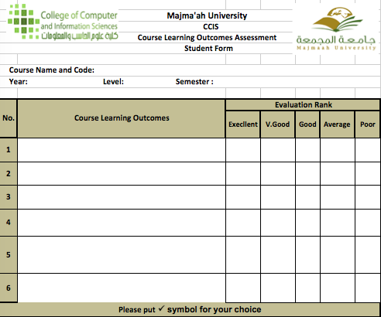
Figure 1.1: Course Learning Outcome template
• All teaching staff participate in self-assessments and cooperates with reporting and improvement processes in their courses
• Creativity and innovation combined with clear guidelines and accountability processes are actively encouraged.
• Mistakes and weaknesses are acknowledged, and dealt with constructively, with help given for improvement.

Use of Performance Indicators and Benchmarks
The quality assurance unit measures NCAAA Key Performance Indicators and Internal and external benchmarks are used wherever possible to evaluate where the program stands. KPIs are analyzed and the improvement plan is suggested.

Overall Evaluation for Quality of the Standard:
Strengths:
- Quality Assurance manual is available for faculty
- All stake holders are involved in developing required reports
- Trainings are given for faculty members on NCAAA course specifications and NCAAA course reports
- Faculty members measure the PLOs from their courses at the end of the semester
- Quality Assurance Unit monitors the progress of course evaluations by the faculty members
Areas and priorities for Improvement:
- Strengthen the Quality Assurance and Management Plan implementation process for consistency of quality assurance practices and monitoring of KPIs for continuous improvements.
- Modify or supplement existing surveys to assess the quality issues currently not assessed.
- Proper and timely feedback of analysis results needs to be provided to planners (teaching staff, course conveners and HODs) to ensure quality improvement.
- Evaluation and any revisions in QA arrangements for the program should be documented and communicated to faculty, concerned staff and Quality &Development.
Action recommendations:
- Provide feedback to the program management on improvement plan based on PLO assessment and KPI scores
- Update the survey formats as per the new requirements of NCAAA

Evidences:
1-1 Program Regulations and Evaluations
1-2 Quality_Manual

Standard 2. Teaching and Learning
Learning outcomes at the program level must be precisely defined, consistent with the requirements of the National Qualifications Framework, and the labor market requirements. The teaching staff must implement diverse and effective teaching and learning strategies and assessment methods that are appropriate to the different learning outcomes. The extent of achievement of learning outcomes must be assessed through a variety of means and the results are used for continuous improvement.
Levels of Evaluation  Elements of Evaluation |  | NA | Not Satisfactory |  | Satisfactory
 |  |  | Non-Compliance | Minimal Compliance | Substantial Compliance | Full Compliance
 |  |  | 1 | 2 | 3 | 4
2-1 | Learning Outcomes
2-1-1 | The program identifies its intended learning outcomes that are consistent with its mission and the graduate attributes at the institutional level; which should be approved, publicly disclosed, and periodically reviewed. |  |  |  |  | P
2-1-2 | The learning outcomes are consistent with the requirements of the National Qualifications Framework, and labor market needs. * |  |  |  |  | P
2-1-3 | The program identifies the learning outcomes for the different tracks (if any). | P
2-1-4 | The program applies appropriate mechanisms and tools for measuring the learning outcomes, and verifying their achievement according to specific performance levels and assessment plans. * |  |  |  |  | P
2-1-5 | The Program implements a clear and approved teaching, learning and evaluation strategy that articulates its educational philosophy and ensures that the Program's intended learning outcomes are achieved. |  |  |  |  | P
2-2 | Curriculum
2-2-1 | The curriculum design considers the fulfilling of the program goals and learning outcomes, and the educational, scientific, technical, and professional developments in the field of specialization; and should be periodically reviewed. * |  |  |  |  | P
2-2-2 | The study plan ensures the balance between the general and specialty requirements, and between theoretical and applied aspects; and it takes into account the sequencing and integration of the courses. * |  |  |  |  | P
2-2-3 | The learning outcomes in the courses are aligned with the program learning outcomes (e.g., Matrix for the alignment of the learning outcomes of the courses with program learning outcomes). (If any) |  |  |  |  | P
2-2-4 | The program ensures a unified application of its study plan as well as the program and the course specifications offered at more than one location (sections of male and female students). * |  |  |  |  | P
2-3 | Quality of Teaching and Students' Assessment
2-3-1 | The program monitors the commitment of the teaching staff to the learning and teaching strategies and assessment methods that are included in the program and course specifications by specific mechanisms. * |  |  |  | P
2-3-2 | The variation of the teaching and learning strategies and assessment methods in the program based on its nature and level, and should be aligned with the learning outcomes of the program. |  |  |  | P
2-3-3 | Provide the necessary training for the teaching staff on learning and teaching strategies and assessment methods that are identified in the program and course specifications, along with the effective use of modern and advanced technology; and their use is monitored. |  |  |  |  | P
2-3-4 | At the beginning of each course, students are provided with comprehensive information about the course, including learning outcomes, teaching and learning strategies, and assessment methods and dates, as well as what is expected from them during the study of the course and feedback on their performance is provided for them. |  |  |  |  | P
2-3-5 | The program applies mechanisms to support and motivate excellence in teaching, and encourages creativity and innovation of the teaching staff. |  |  |  | P
2-3-6 | The program implements clear and publicized procedures to verify the quality and validity of the assessment methods, and to ensure the level of student achievement. |  |  |  | P
2-3-7 | Effective procedures are used to control academic integrity at the program level to ensure that the works and assignments of students are from their own. * |  |  |  |  | P
Overall Evaluation of the Standard
Total Sum of Evaluation of Criteria  (Total Sum of Points) |  | 56
Number of Applicable Criteria |  | 15
Average Evaluation of the Standard |  | 3.73
Overall Quality Rating of the Standard |  | 4
* Essential Criteria

Comments on Results:
Provide an analytical and evaluation report in this section about the results of each standard based on required data, evidence, and related KPIs. (Please link the analysis with the PLOs assessment contained in the Program Report for the last two years in addition to discussing the program's performance on each criterion).

2-1 Learning Outcomes
Knowledge and Understanding:
K1 |  | An ability to understand a problem and identify the computing requirements appropriate to its solution
Skills:
S1 | Analyze a complex computing problem and to apply principles of computing and other relevant disciplines to identify solutions
S2 | Design, implement, and evaluate a computing-based solution to meet a given set of computing requirements in the context of the program’s discipline
S3 | Communicate effectively in a variety of professional contexts
S4 | Identify and analyze user needs and to take them into account in the selection, creation, integration, evaluation, and administration of computing-based systems.
S5 | An ability to apply knowledge of computing and mathematics appropriate to the discipline
Values, Autonomy, and Responsibility:
V1 | Function effectively as a member or leader of a team engaged in activities appropriate to the program’s discipline
V2 | Recognize professional responsibilities and make informed judgments in computing practice based on legal and ethical principles

Assessment Methods for PLOs
 | Assessment Methods of Program Learning Outcomes
Assessment Methods |  |  | PLOs
 |  | K1 |  | S1 | S2 | S3 | S4 | S5 | V1 | V2
Final Exam |  | √ |  | √ |  |  |  | √ |  | √
Mid-Terms |  | √ |  | √ |  |  |  | √ |  | √
Quizzes |  | √ |  | √ |  |  |  | √ |  | √
Class Test |  | √ |  | √ |  |  |  | √ |  | √
Assignments |  | √ |  | √ | √ | √ |  |  |  | √
Practical Exam |  |  |  |  | √ |  | √ | √
Lab Assignments |  |  |  |  | √ |  | √ | √
Group Assignments |  |  |  |  |  | √
Mini Project |  |  |  |  | √ | √ | √ |  | √
Case Study |  |  |  |  | √ | √ | √ |  | √

2-2 Curriculum
Level | Course  Code | Course Title | Required  or Elective | Pre-Requisite  Courses | Credit  Hours | Type of requirements  (Institution, College, or Program)
Level  1 | IT 601 | Cybersecurity Foundations | Required | N/A | 3 | Department
 | IT 602 | Digital Forensics Technology and Practices | Required | N/A | 3 | Department
 | IT 603 | Information Security Law, Policy, and Ethics | Required | N/A | 3 | Department
Level  2 | IT 604 | Cybersecurity Technology and Management | Required | N/A | 3 | Department
 | IT 6XX | Elective- Group A | Elective | IT 601 | 3 | Department
 | IT 6XX | Elective- Group B | Elective | IT 602 | 3 | Department
Level  3 | IT 605 | Research Methods and Engineering Statistics | Required | IT 604 | 3 | Department
 | IT 6XX | Elective- Group A | Elective | N/A | 3 | Department
 | IT 6XX | Elective- Group B | Elective | N/A | 3 | Department
Level  4 | IT 650 | Research Project | 3( 0, 0, 6) | IT 605 | 3 | Department

Program learning Outcomes Mapping Matrix
Course code & No. |  |  | Program Learning Outcomes
 | Knowledge and understanding |  |  |  |  |  |  | Skills |  |  |  | Values, Autonomy, and Responsibility
 | K1 | K2 |  | K3 | --- | S1 | S2 |  | S3 | S4 | S5 | V1 | V2 | ----
IT 601  Cybersecurity Foundations | I |  |  |  |  | I |  |  |  |  |  | I
IT 602  Digital Forensics Technology and Practices | I |  |  |  |  | I | I |  |  | I |  |  | I
IT 603  Information Security Law, Policy, and Ethics | I |  |  |  |  | I |  |  | I |  |  | I | I
IT 604  Cybersecurity Technology and Management | P |  |  |  |  | P |  |  | P |  |  | P | P
IT 605  Research Methods and Engineering Statistics | M |  |  |  |  | M |  |  | M |  | M | M | M
Electives
 | K1 |  |  |  |  | S1 | S2 |  | S3 | S4 | S5 | V1 | V2
IT 611  Network and System Security | P |  |  |  |  | P | P |  |  |  |  |  | P
IT 612  Malware and Vulnerability Analysis | P |  |  |  |  | P | P |  |  |  |  |  | P
IT 613  Cryptography and Cryptanalysis | P |  |  |  |  | P | P |  |  |  |  |  | P
IT 614  Software Security | M |  |  |  |  | M | M |  |  |  |  |  | M
IT 615  Penetration Testing and Ethical Hacking | M |  |  |  |  | M | M |  |  | M |  |  | M
IT 616  Special Topics in Cybersecurity | M |  |  |  |  | M | M |  |  |  |  |  | M
IT 621  Computer Forensics and Investigations | P |  |  |  |  | P | P |  |  |  |  |  | P
IT 622  Advanced Computer Forensics | M |  |  |  |  | M | M |  |  | M |  |  | M
IT 623  Mobile and Network Forensics | P |  |  |  |  | P | P |  |  |  |  |  | P
IT 624  Malware Development and Countermeasure | P |  |  |  |  | P | P |  |  |  |  |  | P
IT 625  Forensics Management of Digital Evidence | P |  |  |  |  | P | P |  |  |  |  |  | P
IT 626  Digital Forensics Response and Analysis |  |  |  |  |  | M | M |  |  | M | M |  | M
IT 627  Special Topics in Digital Forensics |  |  |  |  |  | M | M |  | M |  | M | M | M
IT 650  Research Project | M |  |  |  |  | M | M |  | M | M | M | M | M

2-3 Quality of Teaching and Students' Assessment
PLO assessment process
The assessment of program learning outcomes is performed every semester through direct and indirect assessments. All student outcomes are considered to be attained when the average score reaches 70% and above.
Direct assessment:
  - The assessment is performed on the defined assessment tools for all the courses. The assessment tools are provided in the course portfolio.
Indirect assessment:
  - This is mainly used as a supplementary assessment measure and is done through the Course Learning Outcome measurement survey
Assessment Methods Description
  - The direct assessment is evidence of program learning outcome. It is measurable and tends to be more compelling evidence of exactly what students have and does not learned. The evidence of students’ performance to determine what they’ve learned is available in the course portfolio.
  - The direct assessment methods used are assignments, midterm exam,quiz, laboratory experiments, presentations, final exams, projects etc
  - Indirect assessment evidences tend to be composed of proxy signs that students are probably learning. An example of indirect evidence is a survey through which asking students their self-report that what they have learned. This is evidence that students probably are learning what they report to have learned, but it is not as compelling as a faculty member looking at students’ work. It is not uncommon in students’ self-reports to either inflate or undervalue what they have learned.
  - Course assessment report is a consolidated evidence by the instructor of each and individual section. It contains the data collected from direct and indirect assessments, which were practiced during semester. The information is gathered using several instruments at regular intervals. For example, an exit survey is a data collection instrument that is used to gather information about the graduating students’ opinion to measure the SOs achievement. These instruments are described in detail at later sections.

Non-Discrimination Policy
- MU-CCIS does not discriminate based on race, color, religion, national origin, sex, age, or handicap.

- The Majmaah University-CCIS complies with the Civil Rights Act of KSA

- Majmaah University - CCIS complies with the KSA Disabilities Act.

- No qualified individual with a disability are excluded from participation in; be denied the benefits of; or be subjected to discrimination in any activity, service, or program of the MU-CCIS solely by reason of disability.

- Each qualified individual with a disability who meets the academic and technical standards required to enroll in and participate in MU-CCIS programs are provided with equal access to educational programs in the most integrated setting appropriate to that person’s needs through reasonable accommodation.

- It is the student’s responsibility to initiate the process for disability services.

- The process for obtaining a reasonable accommodation is interactive and begins with the student’s disclosure of disability and a request for reasonable accommodations.

- The student is responsible for providing Student Support Services with documentation not more than three years old of disability from a licensed professional which sets forth the recommended accommodations.

- Documentation is required at the beginning of each academic year and instructors should be notified before the start of each course.

- Student requests for accommodations are considered on an individual basis.

KPI-PG-5 | Rate of students dropping out of the program | 21%  (In First Semester) | 10% | - | -
KPI-PG-5 indicates students dropout rate is 21% when compared to the expected 10%. It should be monitored to identify the difficulties of the students.
Overall Evaluation for Quality of the Standard:
Strengths:
- Evaluation and planning for quality improvement are integrated into administrative processes. Staffs participate in self-assessment and reporting through course reports and different committees with assigned tasks.
- Quality evaluation procedures deal with all aspects of program planning and delivery.
- Quality evaluation surveys and reports provide over view for the performance of program as a whole.
- Evaluations surveys and KPI monitoring are main tools beside others to ensure compliance with the standards.
- Surveys are conducted and reported for male and female students simultaneously and results compared.
- Survey data is collected, analyses and reported. Data on KPIs, grade distributions, and progression and completion rates are retained with the Quality unit, regularly reviewed and reported in annual program reports.

Areas and priorities for Improvement:
- Proper and timely feedback of analysis results needs to be provided to planners (teaching staff, course conveners and HODs) to ensure quality improvement.
- Evaluation and any revisions in QA arrangements for the program should be documented and communicated to faculty, concerned staff and Quality &Development.
- Improve mechanism for teaching and other staff evaluates their own performances in different areas of activities, identify weaknesses and how to correct them, strengths and how to build on them as well as demonstrate plans for future improvement.
- Students’ dropout rate need to be reduced.
Action recommendations:
- PLOs assessment results should be analyzed for not achieving less than 70%
- If PLOs are not achieved more than 70% improvement plan need to be suggested
- Students’ dropout rate need to be analyzed and the steps should be taken to reduce it.
Actual Target
KPI-PG-8 | Ratio of students to faculty members | 5:1 | 6:1 | - | -
KPI-PG-8 value 5:1 indicates that sufficient faculty are available in the program to deliver the program as per the expectations of the students.

Evidences:
2-1 Program Regulations and Evaluations
2-2 Program Specification
2-3 Quality Manual
2-4 General Policies and Procedures

Standard 3. Students
The criteria and requirements of student admissions in the program must be clear and publicly disclosed, and must be applied fairly. The information about the program and the requirements for completion of the study must be available, and students must be informed about their rights and duties. The program must provide effective guidance and counseling services, and extracurricular and enriching activities to its students. The program must evaluate the quality of all services and activities offered to its students and improve them. The program must follow its graduates.
Levels of Evaluation  Elements of Evaluation |  | NA | Not Satisfactory |  | Satisfactory
 |  |  | Non-Compliance | Minimal Compliance | Substantial Compliance | Full Compliance
 |  |  | 1 | 2 | 3 | 4
3-0-1 | The program applies approved and disclosed criteria and requirements for the admission, registration and graduation of students, the transition to another program and the equivalent of what students have previously learned, commensurate with the nature of the program and are applied fairly. |  |  |  |  | P
3-0-2 | The program provides basic information to students, such as study requirements, services, and financial fees (if any), through various means. |  |  |  |  | P
3-0-3 | Students are provided with effective academic, professional, psychological, and social guidance, and counseling services through qualified and sufficient staff. * |  |  |  | P
3-0-4 | Mechanisms are applied to identify gifted, creative, talented, and underachieving students in the program, and appropriate programs are available to care for, motivate, and support each group of them. |  |  |  | P
3-0-5 | The program implements an effective mechanism to communicate with its alumni and involve them in its events and activities, explore their views, and benefit from their expertise and support; and provides updated and comprehensive databases about them. |  |  |  | P
3-0-6 | Effective mechanisms are applied to evaluate the adequacy and quality of services provided to students and measure their satisfaction with them; and the results are used for improvement. * |  |  |  |  | P
Overall Evaluation of the Standard
Total Sum of Evaluation of Criteria  (Total Sum of Points) |  | 21
Number of Applicable Criteria |  | 6
Average Evaluation of the Standard |  | 3.5
Overall Quality Rating of the Standard |  | 4
* Essential Criteria

- Student Admissions
In general, students applying to the college are centrally admitted by the deanship of admission and registration to the preparatory year. The University council decides the number of admitted students for each upcoming year according to the recommendation of the college council, which in turn take recommendations from the department council.
For a student to be admitted to the College of Computer and Information Sciences, the following conditions must be satisfied:
Student’s requirements

- BS or BSc degree in Computing domain, such as CS, IT, IS, CE, or a related field (degree in other field is accepted only if candidate has either previous work experience or in-service training in IT)

Admission requirements: https://www.mu.edu.sa/sites/default/files/content/2018/09/Conditions.pdf

B. Curriculum:
1. Curriculum Structure:
Program Structure | Required/ Elective | No. of courses | Credit  Hours | Percentage
Course | Required | 5 | 15 | 50
 | Elective | 4 | 12 | 40
Graduation Project (if any) |  | 1 | 3 | 10
Thesis (if any)
Field Experience(if any)
Others (.....)
Total |  | 10 | 30 | 100
2. Program Courses:
Level | Course  Code | Course Title | Required  or Elective | Pre-Requisite  Courses | Credit  Hours | Type of requirements  (Institution, College, or Program)
Level  1 | IT 601 | Cybersecurity Foundations | Required | N/A | 3 | Department
 | IT 602 | Digital Forensics Technology and Practices | Required | N/A | 3 | Department
 | IT 603 | Information Security Law, Policy, and Ethics | Required | N/A | 3 | Department
Level  2 | IT 604 | Cybersecurity Technology and Management | Required | N/A | 3 | Department
 | IT 6XX | Elective- Group A | Elective | IT 601 | 3 | Department
 | IT 6XX | Elective- Group B | Elective | IT 602 | 3 | Department
Level  3 | IT 605 | Research Methods and Engineering Statistics | Required | IT 604 | 3 | Department
 | IT 6XX | Elective- Group A | Elective | N/A | 3 | Department
 | IT 6XX | Elective- Group B | Elective | N/A | 3 | Department
Level  4 | IT 650 | Research Project | 3( 0, 0, 6) | IT 605 | 3 | Department

Summary of study plan: https://www.mu.edu.sa/sites/default/files/content/2018/09/Shortest_Plan.pdf

Courses brief Details: https://www.mu.edu.sa/sites/default/files/content/2018/09/Courses%20Descriptions.pdf

- Evaluating Student Performance
After assigning an academic advisor for each student in the program, the student is required to meet his/her academic advisor for the purpose of registration based on his/her study plan, addressing any academic or career issues, and meeting graduation requirements. Each student has his/her own study plan based on the progress in his/her academic study and his/ her choice of the program's tracks. The student is required to maintain an updated study plan each semester to help him/her in choosing appropriate courses for registration in the following semester and to easily follow up the academic progress. The study plan is available for both students and academic advisors.

The performance of the student in his/her courses is evaluated by the instructor using course assessment tools such as final exams, midterms, quizzes, homework, projects, reports etc. that fulfill the course/student outcomes. The instructors are invited to submit list of students who suffer difficulties in their classes to academic advisors. This will help the advisors to present assistance to those students in order to improve their performance in the class. In addition, students are encouraged to stop by their instructor's office during the office hours to discuss with them any concerns regarding the course.

Examination and Grading

Grade Distribution
The full mark for every course is 100, which is typically distributed as follows:
20 Marks for Midterm Exam
40 Marks for Final Exam that covers the entire course contents.
40 Marks for Semester work such as: verbal and written tests, reports or research work or additional studies, experimental lab, and weekly or monthly homework.
Instructors could alter this distribution given that the grade of the Final Exam does not exceed 60% of the total course grade, in addition to at least one midterm exam for no less than 20% of the total course grade.

Examination
The overall marks of any course is calculated as following
- Sixty (60) marks out of one hundred (100) for student work during the semester that includes at least one written midterm and one or more of the following choices
- Written midterm
- Quizzes
- Oral exams
- Projects
- Presentations
- Class Activities
- Laboratory work
- Research
- Forty (40) marks for the final examination that designated during the last week of each semester of the academic year.

Table 1.1 shows the grading system used at Majmaah University. The table shows that each letter grade has a numeric value represented by points. The points of each course are based on this number value and the credit hour value of that course. The following table shows the letter grades and their related points, course grade, and mark.

Table 3.1: Grading System at Majmaah University
Grade | Points | Course Grade | Mark
A+ | 5.00 | Excellent Plus | 95 – 100
A | 4.75 | Excellent | 90 less than 95
B+ | 4.50 | Very Good Plus | 85 less than 90
B | 4.00 | Very Good | 80 less than 85
C+ | 3.50 | Good Plus | 75 less than 80
C | 3.00 | Good | 70 less than 75
F | 1.00 | Fail | Less than 70
IC |  | Incomplete
IP |  | In process
W |  | Withdrawal
DN | 0.00 | Deprivation

Courses with a grade of IC, IP, and W carry no grade value. The grade of incomplete (IC) initially carries no grade value for courses that require more than one semester. The Department Council responsible for that course may allow the student to complete the requirements of any course in the following semester on the basis of a recommendation by the instructor of the course. The student then receives (IC) grade in his/her academic record and it is not calculated in his/her semester average nor in his/her accumulative average unless he/she fulfills the requirements of that course. If one academic semester passes without changing the (IC) grade in the student’s record due to not fulfilling the course, the (IC) grade is replaced by (F) which is calculated in his/her semester average and in his/her accumulative average.

The grade of In Process (IP) initially carries no grade value for research courses that require more than one semester. The student then receives (IP) grade in his academic record and it is not calculated in his semester average or in his accumulative average. If the requirement of that course is not finished within the proposed period, the Department Council which is responsible for that course may replace (IP) grade by (IC) grade.

The deprivation (DN) grade, resulted from more than 25% absence rate in a course, carries a “0” points and included in the accumulative average.

Semester and Accumulative Average
Semester GPA (or GPA in short) is resulted by dividing the sum of the points obtained by the student in all courses he/she studied during any individual semester by the total number of credit hours of those courses.

Accumulative GPA (or AGPA) is resulted of dividing the sum of points obtained by the student in all the courses that he/she has studied during his study in all semesters by the number of units representing those courses.

Attendance
Absences are counted from the first day of the semester. The student must regularly attend all lectures and practical lessons. The student will not be allowed to participate in the final examinations if his/her percentage of attendance is less than (75%) of the lectures and practical lessons allotted for the course.
The student who is deprived of attending the final examination will fail that course and have grade DN, unless he/she provides an excuse accepted by the College Council under the condition that he/she was not less than 50% of attendance.

- Advising and Career Guidance
Vice Dean of Scientific Research, HoD and senior faculty members are responsible for advising & career guidance.

Role of the Academic Advising Unit
The goal of academic advising unit is to connect faculty members with students through following-up, guidance and observation of students academically. This process can be achieved through:

- Welcoming the new students in their first day of the academic year, and notifying them of the University and College systems and the environments.
- Distributing the students according to their specialties all over the college staff.
- General supervising of Academic advisors and following up what are raised to him from student cases.
- Resolving the cases that are raised to him from academic advisors or raising them to the academic vice dean or the dean according to the situation.
- Organizing events and meetings with students at various levels related to academic advising.

Enrollment Advising
The academic advising unit is primarily responsible for advising students prior to the start of each academic year. The unit allocates groups of students to faculty members, which, in turn, is recorded into the university’s electronic registration system, EduGate. The student can see his/her advisor’s name in the electronic registration system, and the advisor has access to the records of his/her advisees through the EduGate portal.

Role of the Academic Advisor
Academic advisors are meant to provide educational counseling for students. The academic advisor's primary responsibility is to evaluate the student’s study plan to ensure it will satisfy university requirements while it meets each student's specific needs. To be effective, the advisor must recognize that each student has different abilities, interests, aspirations, needs, experiences, and problems so that his/her approach in dealing with students can be different from one to another. Academic advising cannot, therefore, be a mechanical, routine matter. To fulfill this requirement, the general advising duties can be stated as follows:

- Students are encouraged to meet with their academic advisors regularly during the semester for consultation and guidance. The relation between academic advisors and students can be summarized as follows:
- Revising and studying the student academic register, including the courses studied and his academic plan and its data. This is to ensure that each student comply with the study plan he/she enrolled in and to avoid delays in graduation
- Helping student in choosing the courses among his academic program.
- Following up the student continuously, and resolving the problems that may appear during his study.
- Raising statistical reports about the department students to the department chief.
- Preparing a complete file for each student advised by him, including his academic schedule, transcript, study plan and attendance during current semester.
- Academic advisors are requested to conduct group meeting with all students at the beginning of each semester.
- Advisors should regularly follow up student 4 times during the term to check his/her attendance and academic progress rate during fifth, eighth, eleventh and fourteenth weeks.
- Students can meet his advisors in other times during the semester to discuss any academic-related issues that may arise and be of concern to the study progress of any student.

Career Advising
Career advising is provided to the students through academic advisors, industry/governmental affiliates, experts in the fields, etc. and organized by the Academic Advising Unit. The college is to start holding an annual event starting from this academic year for the purpose of providing potential graduates with different career paths within their business field, the basic rules of choosing career, identifying and comparing various job opportunities, preparing well for personal interview and improving interview skills. In addition, potential graduates will participate in on-site visits to companies in their field to raise their awareness and to train them on practical interviews, and writing professional CV’s.

- Graduation Requirements
In order to earn the MSCSDF degree from College of Computer and Information Sciences at Majmaah University, the student must complete the following requirements:
The MS in CSDF degree is comprised of 30 credits hours of graduate study which include 15 credits core courses, six credits from Cybersecurity or related domains, six credits from digital forensics or related domains, and three credits Research Project.

Program Study Plan Requirements
Shortest_Plan.pdf (mu.edu.sa)

The overall grade of AGPA for the student at graduation is considered as:

- Excellent: If AGPA is greater or equal to 4.5.
- Very Good: If AGPA is greater or equal to 3.75 and less than 4.5.
- Good: If AGPA is greater or equal to 2.75 and less than 3.75.
- Pass: If AGPA is greater or equal to 2 and less than 2.75.

- Transcripts of Recent Graduates

The program will provide transcripts from some of the most recent graduates to the visiting team along with any needed explanation of how the transcripts are to be interpreted.

- Evaluation
Assessment Process
The assessment and evaluation of SOs(PLOs) of an individual course during the semester based on data collection is explained in details:

- Data Collection
- The direct assessment is evidence of student outcome. It is tangible, visible, measurable and tends to be more compelling evidence of exactly what students have and does not learned. The evidence of students’ performance to determine what they’ve learned is available in the course portfolio.
- Indirect assessment evidences tend to be composed of proxy signs that students are probably learning. An example of indirect evidence is a survey through which asking students their self-report that what they have learned. This is evidence that students probably are learning what they report to have learned, but it is not as compelling as a faculty member looking at students’ work. It is not uncommon in students’ self-reports to either inflate or undervalue what they have learned.
- Course assessment report is a consolidated evidence by the instructor of each and individual section. It contains the data collected from direct and indirect assessments, which were practiced during semester. The information is gathered using several instruments at regular intervals. For example, an exit survey is a data collection instrument that is used to gather information about the graduating students’ opinion to measure the SOs achievement. These instruments are described in detail at later sections.
- Data Preparation: The data preparation involves validation and transformation to make it ready for use in evaluation of PLOs (SOs).
Evaluation Processes
- Data Interpretation: Metrics are used to summarize data and its interpretation based on the points of interest. For example, the survey responses are used to calculate weighted averages scored of PLOs(SOs).
- Attainment Evaluation: The attainment of evaluation for all the PLOs(SOs) are measured in this step. For example, the verification of the SO achievement from various data sources with reference to the threshold values (EE-Exceeding Expectation, ME-Meeting Expectation, & DNME-Does Not Meet Expectation) are carried out.
Exceeds  Expectations  (EE) | Meets  Expectations  (ME) | Does  Not Meet  Expectations  (DNME)
>=80% or more of  students are  achieving the  satisfactory level  or above | >=70% and <80%  of students are achieving the  satisfactory level or above | < 70%  of students are not  achieving the  satisfactory level

- Issue Analysis: Wherever the evaluation of targeted SOs are not achieved, an issue based deeper analysis is conducted. For example, reviewing faculty course assessment reports, discussing with faculty and students to determine underlying issues for poor achievement.
- Improvement plan: An action plan is developed to remedy the identified issues and recommended implementation over the issue.
Figure 3.1 summarizes assessment and evaluation of PLOs

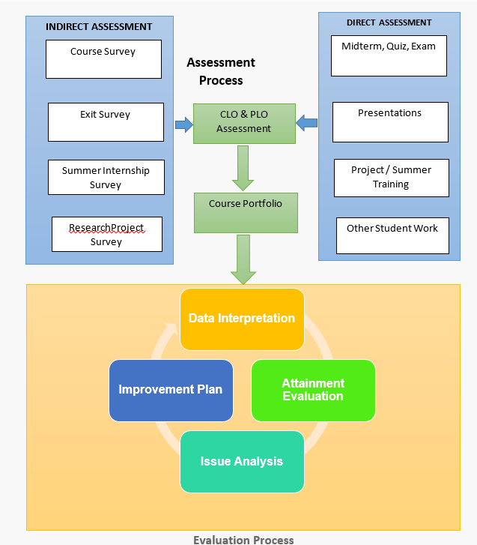
Figure 3.1: Assessment and Evaluation Processes

- Program Learning Outcome
Program Learning Outcomes:
Knowledge and Understanding:
K1 |  | An ability to understand a problem and identify the computing requirements appropriate to its solution
Skills:
S1 | Analyze a complex computing problem and to apply principles of computing and other relevant disciplines to identify solutions
S2 | Design, implement, and evaluate a computing-based solution to meet a given set of computing requirements in the context of the program’s discipline
S3 | Communicate effectively in a variety of professional contexts
S4 | Identify and analyze user needs and to take them into account in the selection, creation, integration, evaluation, and administration of computing-based systems.
S5 | An ability to apply knowledge of computing and mathematics appropriate to the discipline
Values, Autonomy, and Responsibility:
V1 | Function effectively as a member or leader of a team engaged in activities appropriate to the program’s discipline
V2 | Recognize professional responsibilities and make informed judgments in computing practice based on legal and ethical principles
Strategies applied to achieve program learning outcomes:

NCAAA  Category | NCAAA  Code | SO Descriptor | Teaching Strategies | Assessment Methods
Knowledge | K1 | An ability to understand a problem and identify the computing requirements appropriate to its solution | Classroom Teaching | Class Test, Mid Exam, Final Exam
Skills | S1 | Analyze a complex computing problem and to apply principles  of computing and other relevant disciplines to identify  solutions | Classroom Teaching | Class Test, Mid Exam, Final Exam
 | S2 | Design, implement, and evaluate a computing-based solution to meet a given set of computing requirements in the context of the program’s  Discipline | Mini Project, Lab Exercises | Lab Based Assignments, Mini Project
 | S3 | Communicate effectively in a variety of professional contexts | Oral /Written Communication, Seminar | Group Assignments, Mini Project
 | S4 | Identify and analyze user needs and to take them into account in the selection, creation, integration, evaluation, and administration of computing-  based systems. [IT] | Mini Project, Graduation Project, Lab Exercises | Case Study Implementation/ Laboratory /Mini project
 | S5 | An ability to apply knowledge of computing and mathematics  appropriate to the discipline | Classroom Teaching | Class Test, Mid Exam, Final Exam
Values | V1 | Function effectively as a member or leader of a team engaged in activities appropriate to the program’s  discipline | Mini Project, Graduation Project, Lab Exercises | Oral or Written Communication, Seminar
 | V2 | Recognize professional responsibilities and make informed judgments in computing practice based on  legal and ethical principles | Classroom Teaching, Graduation Project | Class Test, Mid Exam, Final Exam

Description of the PLOs assessment process

  - The assessment of student outcomes is performed every semester through direct and indirect assessments. All student outcomes are considered to be attained when the average score reaches 70% and above.

Direct assessment:
  - The assessment is performed on the defined assessment tools for all the courses. The assessment tools are provided in the course portfolio.
Indirect assessment:
  - This is mainly used as a supplementary assessment measure and is done through the following surveys:
  - Course survey
  - Project survey
  - Survey ( on services etc)
Figure 3.2 illustrates the various direct and indirect assessment

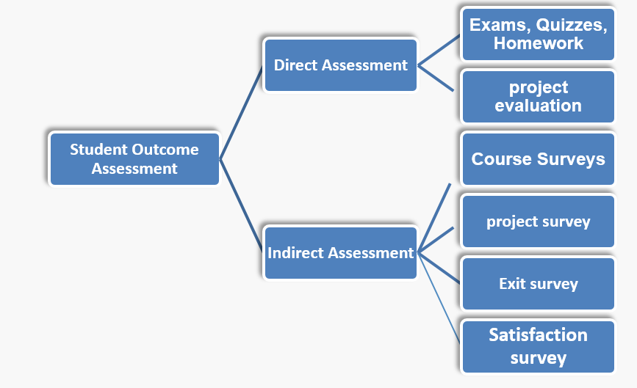

Figure 3.2: Student outcomes assessment
Table 3.2: Students outcomes assessment tools – Direct and Indirect
 | Assessment Tool | Frequency | Media | How Collected | Source | Collected by | Evaluated by
Direct Assessment | Mid exam, Class test, Quiz, Assignment, Final Exam | Every Semester | Course Assessment Report | Electronic | Faculty Members | Quality Unit IT Deptt. | Quality Unit
Indirect Assessment | Course Surveys | Every Semester | Survey | Paper / Electronic | Faculty Members | Faculty Members | Quality Unit
 | Project Surveys | Every Semester | Survey | Paper / Electronic | Faculty Members | Project Coordinator | Quality Unit
 | Other Surveys | Every Semester | Survey | Electronic | Quality Unit IT Deptt. | Quality Unit IT Deptt. | Quality Unit

Direct Assessment
In the IT program (MSCSDF), each course targets a subset of the student outcomes with a certain percentage. These outcomes are directly assessed in every course using pieces of student work (questions in exam, homework, project, etc.,) Specific questions from the desired assessment tools are designed to assess a targeted outcome in the course. The designated level of performance (70% and above) indicates the achievement of PLOs in the course.
In every course, the faculty member is expected to assess the achievements of the relevant student outcomes in the course. The final assessment is preferably done close to the end of the semester.
The faculty member prepares a direct assessment report and evaluates the student outcome achievement in each course. If the assessment revealed any weaknesses in a specific student outcome, the faculty should identify the cause and propose corrective action plan that can be implemented in the course or in one of the prerequisite courses in order to improve that specific outcome achievement in the future.
The proposed corrective actions are implemented in the following semester and their impact on the specific outcome achievement shall be assessed.
The measurement and evaluation unit aggregates the outcomes achievement in all courses in IT program and computes the average score. If an outcome achievement appears to be unsatisfactory, the faculty member/department propose corrective action plan at the course level, the curriculum level, or both.
Different courses contribute to a specific outcome achievement at the program level depending on their number of credit hours and the percentage by which they target that specific outcome.

The student outcomes’ assessment process is conducted every semester.
Each course instructor provides direct assessment reports and outcome evidences:
- Brief description of the student works used to measure the achievement of student outcomes (assignments, projects, exams, etc.),
- A description of which specific work is meant to assess which outcome.
- Student outcomes achievement.
- Analysis of the student outcomes achievements and identifying strengths and weaknesses.
- Proposals to fix any identified weaknesses to be applied during the following semester.
- Samples of students’ work.
Indirect Assessment
The indirect assessment consists of the following processes:
  - Course survey
  - Project survey
  - Survey ( on services etc)

Summary of evaluation results and analysis

Direct student outcomes assessment
For every course, the instructor provides a course assessment report, where they reported the assessment results, identified the weaknesses and proposed corrective actions to improve the student outcome achievement in the following semester. The results from all courses will be aggregated to compute the student outcome achievement at the program level at the end of every semester. The assessment will be based on the mapping of the exams, homework and assignments with specific student outcomes. The averages of students’ marks in a specific assignment/question will be used as the achievement of the corresponding student outcomes.
Attainment of MSCSDF Program Education Objectives (PEOs) for 2021-22 & 2022-23 by Direct Assessment

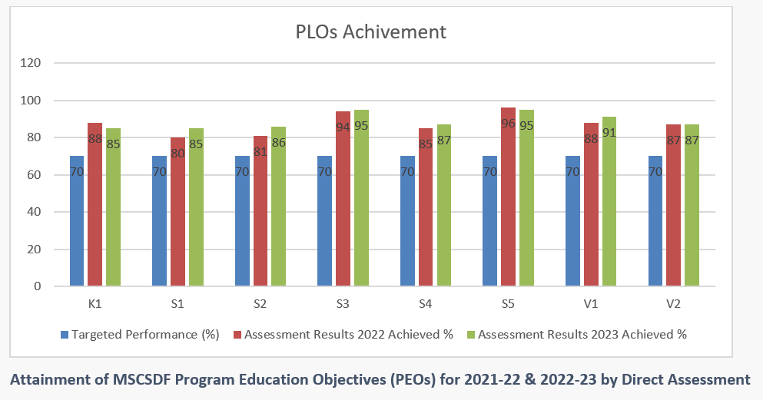

Analysis Direct assessments:
- Results shown in the above table prove that the students in 2021-22 & 2022-23 have attained all the outcomes above than targeted value.
- It is noted from the Course Report that in 2022-23 in Course IT 601 ,no of failures are high ( 30%) , IT 602 ( no.of failure are 22%) .Number of failed students in this batch is higher than usual, main reasons include poor English language skills and irregular attendance. In other course results are satisfactory
- The average of outcome of all courses are above than targeted vale in both the years

2021- 2022 & 2022-23 : PLOs and Program education objectives (PEOs) attainment
2021- 2022: PLOs and Program education objectives (PEOs) attainment

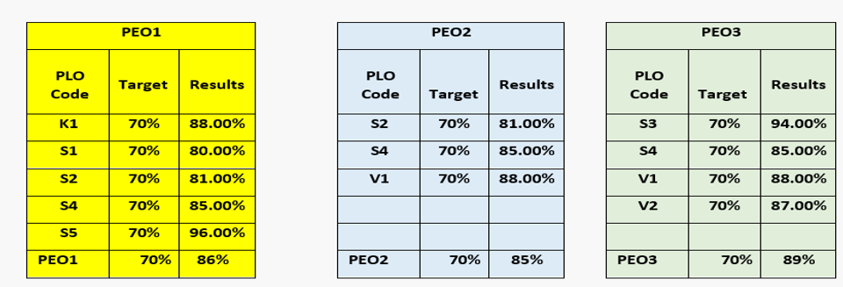
Comments: PEO1, PEO2 and PEO3 are exceeding expectations (EE) level (above than 80%) in 2021-22.

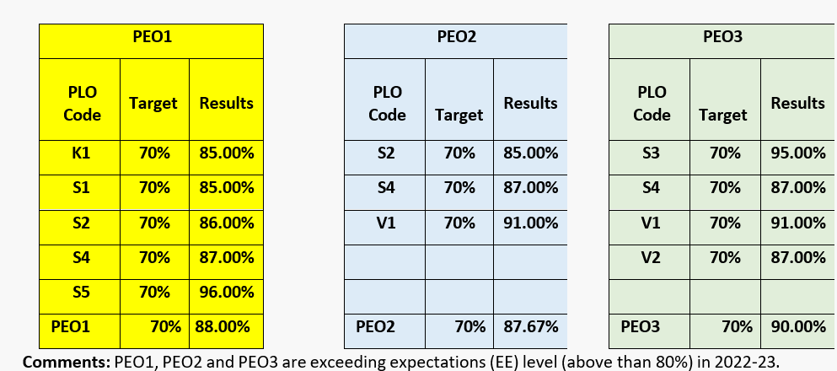
Comments: PEO1, PEO2 and PEO3 are exceeding expectations (EE) level (above than 80%) in 2022-23.
Improvement Plan:
1. Retain the plan and target level may be increased to 80%.
All PLOs attainments above than targeted and in Exceeding expectation (EE- 80% and above) due to efficient teaching learning process
Analysis Indirect Direct assessments (2021-22 & 2022-23)
MSCSDF Survey Response -2022-23.pdf
MSCSDF Survey Responce 2021- 2022.pdf
Students Survey for Study Plan Satisfaction.pdf
Students Survey for Quality of Learning Experience and Lab and Learning Resources (1).pdf
Student Satisfaction Survey will be conducted online from AY 2021-202 and 2022-23. The result was shown positive response from the MSCSDF students regarding the Program performance about overall institutional performance of teaching, learning, and evaluation.
The survey results depicted that 90% students are satisfied on below questions in 2021-22& 2022-23 (response was excellent & good)
- Quality of learning experience in the program
- Quality of the courses taught in Semester 1 ( IT 601,602 & 603) Cyber Security, Digital Forensics
- Quality of scientific supervision
- Satisfaction with the provided services by Department
- Satisfaction with Lab and equipment
Etc…..
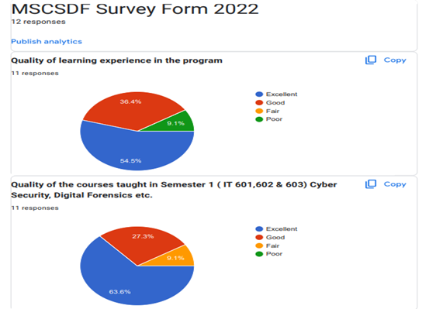
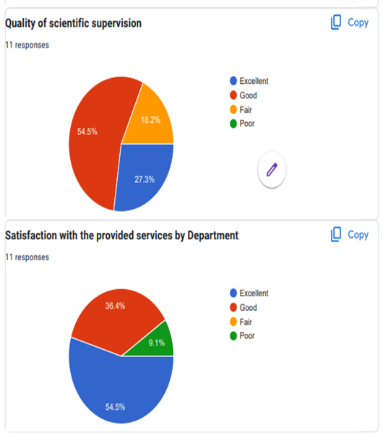
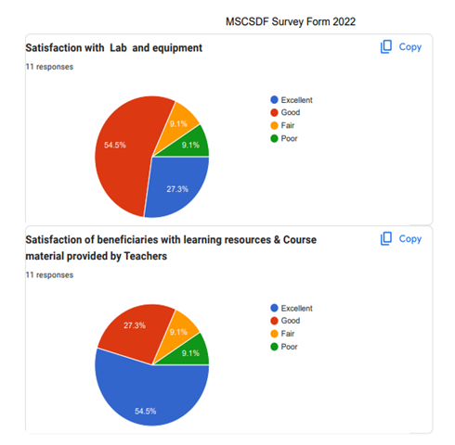
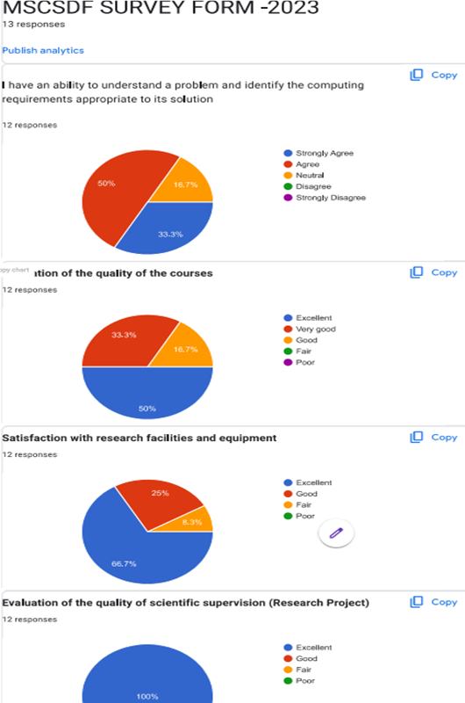

Comments on Results:
Provide an analytical and evaluation report in this section about the results of each standard based on required data, evidence, and related KPIs. (Please link the analysis with the PLOs assessment contained in the Program Report for the last two years in addition to discussing the program's performance on each criterion).

- Criteria and requirements for admission to the program are in place and publicly disclosed, and applied fairly.
- Program information and requirements are available
- Guidance and counselling services are in place,
- Every aspect of the program is evaluated and improved to ensure it meets the needs of its students.
- Direct Assessment -All PLOs attainments above than targeted and in Exceeding expectation (EE- 80% and above) due to efficient teaching learning process.
- Student's research publication shows the quality of program - Measures of professor-student collaboration, faculty dedication to graduate students, and faculty qualities are among the MSCSDF Program determinants of faculty-student publications arising from mentored graduate research. The Publication indicate that faculty mentors at MSCSDF were more successful in publishing jointly with undergraduate students when they worked with them for longer than a year on average, and they also valued imparting research knowledge to students.
- Indirect assessments- Student Satisfaction Survey will be conducted online from AY 2021-202 and 2022-23. The result was shown positive response from the MSCSDF students regarding the Program performance about overall institutional performance of teaching, learning, and evaluation. The survey results depicted that 90% students are satisfied on below questions in 2021-22& 2022-23 (response was excellent & good)
- KPIs related to standard 4 also achieved targeted values.

Overall Evaluation for Quality of the Standard:
Strengths:
- The student learning outcomes are specified after consideration of relevant academic and professional advice. Intended learning outcomes are also consistent with the Qualifications Framework and covering all the domains of learning.
- The intended learning outcomes are consistent with requirements for professional practice in Saudi Arabia.
- Learning outcomes of each course are mapped with the program objectives and are assessed each semester
- Feedback / Response form from students is taken on yearly basis for program improvement
- Teaching learning process is performed by dedicated teachers and other employees
- The institutional environment is conducive for learning.
- The Student community has positive attitude and are cooperative which is helping them to attain better results
- Freedom of work is available to all faculty and staff
- Student faculty ratio is adequate.
- Evaluation and planning for quality improvement are integrated into administrative processes, Progress and matters are discussed in Department and college Council meetings.
- Quality evaluation procedures deal with all aspects of program planning and delivery.
- Quality evaluation surveys and reports provide over view for the performance of program as a whole.
- Evaluations surveys and KPI monitoring are main tools beside others to ensure compliance with the standards.
- Surveys are conducted and reported for male and female students simultaneously and results compared.
- Survey data is collected, analyses and reported. Data on KPIs, grade distributions, and progression and completion rates are retained with the Quality unit, regularly reviewed and reported in annual program reports.
Areas and priorities for Improvement:
- Improve mechanism for teaching and other staff evaluates their own performances in different areas of activities, identify weaknesses and how to correct them, strengths and how to build on them as well as demonstrate plans for future improvement.
- Strengthen the Quality Assurance and Management Plan implementation process for consistency of quality assurance practices and monitoring of KPIs for continuous improvements.
- Modify or supplement existing surveys to assess the quality issues currently not assessed.
- Proper and timely feedback of analysis results needs to be provided to planners (teaching staff, course conveners and HODs) to ensure quality improvement.
- Evaluation and any revisions in QA arrangements for the program should be documented and communicated to faculty, concerned staff and Quality &Development.
- Develop indicators to measure achievement of learning outcomes by the students and the faculty.
Action recommendations:
The main actions that will be taken in the next semester to resolve the issues mentioned previously are as follows:
- Efforts will be taken to supply the feedback forms during the end of the semester and proper advising will be given
- Introduce more exercises and give them small projects to make all the students to reach the level EE
- Implement Learning by Example.
- More attention on Soft skills including communication and language skills.
The following evidence was taken into account to evaluate this section of the standard.
- Program Hand book ( Rules & Regulation)
General Document--Program Regulation etc
- Annual Program Reports
APR
- Program specification
Program Specification
- Sample of Course Specification
Courses Specs (2022)
- Course Report
Courses Reports (2022, 2023)
- Surveys by students to evaluate program outcomes
MSCSDF Survey Response -2022-23.pdf
MSCSDF Survey Responce 2021- 2022.pdf
Students Survey for Quality of Learning Experience and Lab and Learning Resources (1).pdf
Students Survey for Study Plan Satisfaction.pdf

- Students publication (Research papers) - 6-3-2 Research Masters Students 2023,2022.xlsx

Standard 4. Faculty
The program must have sufficient numbers of qualified teaching staff with the necessary competence and experience to carry out their responsibilities. The teaching staff must be aware of current academic and professional developments in their fields of specialization, participate in research and community service, and in improving the program and institutional performance. Teaching staff performance must be evaluated according to specific criteria, and the results of these evaluations must be used for development.
Levels of Evaluation  Elements of Evaluation |  | NA | Not Satisfactory |  | Satisfactory
 |  |  | Non-Compliance | Minimal Compliance | Substantial Compliance | Full Compliance
 |  |  | 1 | 2 | 3 | 4
4-0-1 | The program has an adequate number of faculty members at all campuses where it is offered and appropriate verification mechanisms are applied. * |  |  |  |  | P
4-0-2 | The teaching and adjunct staff in the professional programs include some experienced and highly skilled professionals in the field of the program. |  |  |  |  | P
4-0-3 | The teaching staff participate in academic, research and scientific production activities efficiently and regularly, and their participation in these activities is considered as one of the criteria for their evaluation and promotion. |  |  |  |  | P
4-0-4 | Teaching staff participate in community partnership activities; and their participation in these activities is considered as one of the criteria for their evaluation and promotion. |  |  |  | P
4-0-5 | Teaching staff participate in professional and academic development programs in accordance with a plan that meets their needs and contributes to the development of their performance. |  |  |  |  | P
4-0-6 | The performance of the teaching staff is regularly assessed according to specific and published criteria; feedback is provided to them; and the results are used in improving the performance. |  |  |  |  | P
Overall Evaluation of the Standard
Total Sum of Evaluation of Criteria  (Total Sum of Points) |  | 23
Number of Applicable Criteria |  | 6
Average Evaluation of the Standard |  | 3.83
Overall Quality Rating of the Standard |  | 4

* Essential Criteria

- Faculty Qualifications

The competency and expertise of the Information Technology (IT) Department faculty constitutes the core to the success of the IT Program. The faculty members listed in Table given below have necessary expertise within the curriculum requirements of the IT program (MSCSDF). The Department of IT program MSCSDF has 10 full-time faculty consists of 2 Professor, 3 Associate Professor, 5 Assistant professors. Most of the faculty members have doctoral degrees from reputed universities across the globe. The faculty members in the IT department share diversity in background, race and experience. The departmental faculty members represent a broad range of research expertise. Their expertise encompasses a broad spectrum in the areas of cybersecurity, networks, digital forensics, AI, Machine learning, information security, cloud computing, storage technology etc. Many of them are active researchers in their scientific fields and authors of high-quality research papers published in reputed international journals and conferences.

Table 4.1. Faculty Qualifications: Information Technology Program (MSCSDF)

Faculty Name | Highest Degree Earned- Field & Yr | Rank ¹ | Type of Academic Appointment²  T, TT, NTT | FT or PT³ | Years of Experience | Professional Registration/ Certification | Level of Activity⁴  H, M, or L
 |  |  |  |  | This Institution |  | Professional Organizations | Professional Development | Consulting/RESEARCH
Dr. Mohammed Abdul Rahman AlShehri | PhD(ICT)-2013 | P | T | FT | 8 | IEEE | H | H | H
Dr.Shailendra Mishra | PhD( Network& Security)-2007 | P | T | FT | 10 | IEEE | H | H | H
Dr. Saleh K. Haridy Aly | PhD( AI&IP)-2010 | ASC | T | FT | 7 | IEEE | H | H | H
Dr. Shaik Shakeel Ahamad | PhD( Network& Security)-2014 | ASC | T | FT | 9 | IEEE | H | H | H
Dr. Anul HaQ | PhD( AI)-2013 | ASC | T | FT | 5 | IEEE | H | H | H
Dr. Fahad Suliman Alodhyani | PhD(Computer Science and Informatics)-2022 | AST | T | FT | 8 | - | M | M | M
Dr.Abu Bakar | PhD(CSE)-2010 | AST | T | FT | 9 | - | H | M | H
Dr. Ahmed Ibrahim AlUtaibi | PhD( Network& Security)-2018 | AST | T | FT | 10 | IEEE | M | M | H
Dr. Sultan AlAsmari | PhD( IS)-2022 | AST | T | FT | 10 | IEEE | M | M | M
Dr. Arshiya Sajid Ansari | PhD( Network& Security)-2018 | AST | T | FT | 6 | ISACA, IEEE | H | M | H

1. Code: P = Professor ASC = Associate Professor AST = Assistant Professor
2. Code: TT = Tenure Track T = Tenured NTT = Non Tenure Track
3. At the institution
4. The level of activity, high, medium or low, should reflect an average over the year prior to the visit plus the two previous years.

B. Faculty Workload
The official teaching load of faculty members, as per the regulations of the Majmaah University as follows:
• 10 credit hours for professors
• 12 credit hours for associate professors
• 14 credit hours for assistant professors
• 16 credit hours for lecturers
The workload of faculty members in the department is divided into teaching, research and other services. In terms of teaching they deliver lecture, conduct exercises and lab classes. Faculty members of the department perform service at a number of levels: to the department, to the College, to the University and to the profession in general.

The college has the following supporting units / committees to support the administration:
Quality and Accreditation Unit, Exams Unit, Academic Development Unit, Academic Advising Unit, Labs’ Unit, Students Activities Unit, e- learning and Learning Technology Unit, Students Disciplinary Unit, Scholarship Unit, Measurement and Evaluation Unit, Summer Training Unit, Statistics Unit, College Bulletin Supervisory committee, Discipline Committee, Time Tables and Registration Committee, Research Committee. Faculty members of the department are members of these committee and perform service at a number of levels.

Faculty Size
All IT department faculty members share the responsibility of teaching, advising and service pertaining to the program. The ratio of faculty to students shown in Table below is adequate to accommodate various needs of students including teaching sections with reasonable number of students in each, reserving reasonable office hours for students, advising, as well as allow faculty members to perform other tasks and duties related to research, participation in committees, professional development etc.
Faculty Profile Details- Master-MSCSDF PROGRAM -2024-final.xlsx
Table 4.2. Faculty Student Ratio- MSCSDF Program (2022-23)
No of Faculty member | No of students (Approved-1)  No of Students  (Actual-2) | Ratio of students to faculty members
10 | 1-60  2-44 | 6:1  5:1

Faculty interact and supervise the students during his office hours, each faculty member is asked to define office hours for the course and announces them to the students.
However, students can meet in other times during the semester to discuss any academic-related issues that may arise and be of concern to the study progress of any student.

C. Professional Development

Most of the IT department faculty members are engaged in state, national and international professional service through technical committees and professional leadership roles. Faculty profile shows the professional development activities of the faculty members of IT Department (MSCSDF Program) such as memberships of professional associations (IEEE, ACM etc.), workshops/ conferences/seminars attended or organized, In-Service Training (Conducted/Attended), Member of Curriculum/Assessment/Program Development committee, serving as a volunteer leader, committee chair or board member etc.
Faculty Profile Details- Master-MSCSDF PROGRAM -2024-final.xlsx

Through the university supporting deanships especially through the Deanship of E-Learning & Distance Learning and Deanship of Quality & Skills Development, faculty members received a number of skill and knowledge improving courses and workshops. These covered the main responsibilities required from the faculty members and supporting skills information that can help them fulfill their mission.

Involvement in Research
- IT Department (MSCSDF Program) is committed to producing high quality research that impact across all its subject areas such as Cyber Security, clouding computing, information security, networks and systems administration, web and multimedia applications, database, Storage Technology, and Digital Forensics.
- The IT department expects the faculty members to engage in research and knowledge transfer by applying for funded projects and publish papers in reputed international journals with good impact factor.
- Research is also considered as criteria in the performance evaluation of all the faculty members.
- Clear policies are established in the college for defining what is recognized as research, consistent with international standards and established norms in the field of study of the program as defined in the strategic objectives.
- Support is provided by DSR for publication in IF Journals.
- Assistance is available for teaching staff to develop collaborative research arrangements with colleagues in other institutions and in the international community. The members are funded fully to travel nationally/internationally to present their research work. The faculty members are also suitable awarded to publish the papers in ISI indexed journals.
- Strategies are developed for identifying and capitalizing on the expertise of faculty and postgraduate students in providing research and development services to the community and generating financial returns to the institution. The expertise available with the college is made available in the college website.
- The following dedicated lab for the research is established in the college used by faculty and students of IT department for their research and project work.
  - Cybersecurity & Digital forensics lab
  - Image processing lab
  - Robotics lab
Research Contribution
Faculty members engage in research, thereby contributing to the knowledge base of the discipline and academic field.
Table 4.3. Research Contribution (MSCSDF Faculty Members)

S.No | Google Scholar | Citation & h and i10 index
1 | Dr. Mohammed Alshehri (M. Alshehri) - Google Scholar | AllSince 2019  Citations3098 2194  h-index26 25  i10-index62 58
2 | Dr. Shailendra Mishra, Senior Member IEEE - Google Scholar | AllSince 2019  Citations1037694  h-index1613  i10-index2616
3 | Mohd Anul Haq - Google Scholar | AllSince 2019  Citations20511912  h-index2626  i10-index5951
4 | Saleh Aly, IEEE Senior Member - Google Scholar | AllSince 2019  Citations1151966  h-index1916  i10-index2519
5 | Dr. Shaik Shakeel Ahamad. Ph.D. (University of Hyderabad) & IDRBT - Google Scholar | AllSince 2019  Citations343247  h-index98  i10-index95
6 | Ahmed Alutaibi - Google Scholar | AllSince 2019  Citations1212  h-index22
7 | Ahmed A. Mohamed - Google Scholar | AllSince 2019  Citations209145  h-index85  i10-index64
8 | Fahad Alodhyani - Google Scholar | AllSince 2019  Citations1919  h-index11  i10-index11  0105
9 | Sultan Alasmari - Google Scholar | AllSince 2019  Citations5649  h-index22  i10-index11
10 | Dr. Arshiya S. Ansari - Google Scholar | AllSince 2019  Citations162158  h-index55  i10-index43

- The research strategic plan is established, and the strategic objectives are defined with the KPIs. The research committee headed by the college Dean supervises the research
- Adequate budget and facilities for conducting research at a level consistent with institutional, program and departmental policies are provided. The Annual Research budget is maintained and controlled by the Deanship of Scientific Research, Majmaah University. The Engineering and Applied Sciences Research Centre of Deanship of Scientific Research fund the money to the college based upon the need and justification.
- All the members are encouraged to be the member of all the professional bodies and to become member in the editorial board of reputed international journals
- Research Seminars / Workshops- All the faculty members are invited to attend and get benefitted.
- Training and development
The department offers career and professional development support to all research staff. We continually invest in resources and improve research facilities to ensure that our members are able to pursue their ideas, undertake research and transfer their knowledge to ensure significant global impact.

D. Authority and Responsibility of Faculty

Course Creation, Modification and Evaluation
All curricular changes for the IT program are proposed by IT Department faculty, whether an individual or by a faculty subgroup. Changes to the curriculum are managed by the curriculum development unit, which tables valid proposals to the department council for approval.
Curriculum changes, including course creation, deletion, or modification can be initiated by;
- Faculty members: Faculty member or faculty subgroup submit a proposal for changes including course creation, deletion, or modification based on their motivated opinion, or latest developments in IT area to the curriculum development unit.
- Curriculum development Unit: The Curriculum Development Unit will review the proposal before submitting it to the department council. Curriculum development Unit ensure that proposed changes to the curriculum is aligned with the best international practices.
- The department council: The department council discusses on proposals, if the council approves a curriculum change, the new curriculum is submitted to the college council.
- The college council: The college council discuss the proposal submitted by department council in depth, if college council approves it, then it is submitted to the university scientific council.
- University scientific council: University scientific council which may request an external review before approving the proposal submitted by college council, if university scientific council approves it and send to college/department, the new curriculum becomes effective.
Figure 4.1 shows the process for changes in the curriculum change including course creation, deletion or modification.

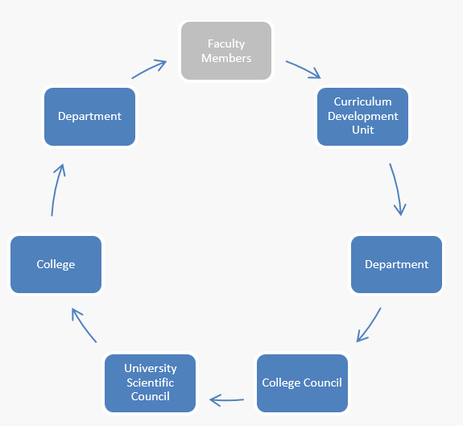

Figure 4.1 Process for changes in the curriculum

Course Evaluation

Course evaluation is a continuous process in which course is evaluated by faculty members and course conveners after final Exam. Final Evaluation of the courses are reported in Course Report (CR). All the course conveners will submit the CR report to the Measurement and Evaluation unit. Measurement and Evaluation unit prepare a consolidated report covering attainment of student’s outcome (PLOs) of all the courses offered during the semester and submit the report to the Quality Unit. Quality unit send the report to Department. The issues raised by the Quality unit will be discussed in department council meeting. Figure 4.2 shows the process of course evaluation after end semester examination.

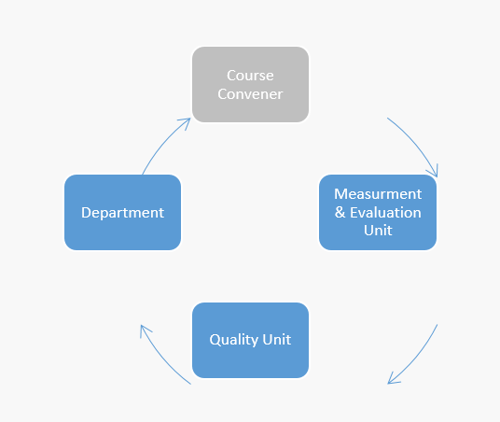

Figure 4.2 Process of course evaluation after final examination

Program Educational Objectives and Student Outcomes
Faculty members play an important and major role in the program and are consequently pivotal in the definition and revision of the program educational objectives and student outcomes. In the information technology department, the faculty members are participating in formulating and maintaining the department mission as well as the initial set of PEOs and approving any PEOs changes. Moreover, they are aware of the establishing and revising the SOs(PLOs) and following up of the assessment process.

Attainment of the Student Outcomes
Faculty members are deeply involved in measuring the attainment of student outcomes. Course Conveners are responsible for defining and updating course learning outcomes and their mappings to student outcomes. Faculty members are responsible for assessing the attainment of student outcomes. Each course is evaluated by direct and indirect measurements. The final assessment is done at the end of every semester aggregated at the course level by the course convener. Course Convener report the percentage of Student Outcomes (PLOs) achieved along with barriers and issues, also plan of action for the next semester. Measurement and Evaluation unit evaluates the attainment of the student outcomes at the program level.

Role of Dean, Vice Dean academic affairs and HODs
Dean is appointed by the Higher Education Minister with recommendation of University rector. The Dean is part of the senior management group within the University acting under delegated authority from the Rector in so doing and reporting directly to the Rector.

Roles in Administration, Academic and Financial Affairs
- Overseeing the management & administration of academic, research, administrative, financial and cultural affairs in college.
- Overseeing the educational process, implementing its plans and developing the academic programs in the college.
- Authority to make recommendations for the appointments of vice-deans and departments chairmen and raise them to the university Rector.
- Approving of department council decisions and resolutions and having the right to veto its decisions within fifteen days from the date of receiving them.
- Authority of performance evaluation reports submitted by college units.
- Authority to make recommendation to contract with a faculty member after his retirement.
- Authority to make recommendation to terminate the contract of non-Saudi faculty member in coordination with the department chairman.
The authority of the Dean extends to all resources and staffing matters within the faculty and staff. The principal role of the Dean is to assist the faculty and components of the faculty to achieve their agreed academic objectives as effectively as possible.

The College Dean advises on program educational objectives, outcomes, and curriculum issues, with an eye to ministry of education and university administration requirements. Dean chairs the College Council, after receiving the proposal from department regarding PEOs, SOs(PLOs) and curriculum change. College council discuss the proposal, if council approve it, Dean will send it to the university scientific council for approval. Besides this, CCIS Dean is involved centrally in issues including strategic planning, budget, curriculum, facilities and research.
Moreover, he is the key participant in external relations of the university, including fundraising, economic development and represent the college in University.
The college Vice dean for academic affairs essentially focuses on the academic and educational affairs in the college. Vice dean for academic affairs is responsible for supervising the academic and educational performance in the college.
Roles in Academic affairs
- Supervising the academic and educational performance in the college.
- Supervising student cultural, social and sport activities.
- Supervising the mission of students' rights in the advising council.
- Supervising field training.
- Supervising academic advising.
- Studying and following up of student affairs.

The Department Chair (HOD) is appointed by the university rector with the recommendation of dean of the college for two renewable years.

Roles in Administration, Academic affairs and Financial Affairs
- Overseeing the organization of its affairs and the invitation to and invitation to attend its meetings, implementing of its resolutions and sending the minutes of its meetings to the Dean of the college.
- Implement the decision of the College Council regarding the department.
- Overseeing the administration of academic, research, administrative, financial and cultural affairs in the department.
- Overseeing the educational process, implementing its plans and developing the academic programs in the department.
- Supervision of the various students’ activities in the department.
- Monitoring the performance of examinations and adjusting the system within the department.
Head of Department (HOD) is responsible and accountable for setting and advancing the academic strategy of the Department in line with Faculty and University strategic plans and direction. HOD Chairs the Departmental Council and contribute to the overall leadership and management of the Faculty, also develop and sustain appropriate structures for management, consultation, decision-making and communication with staff and students. HOD advises on program educational objectives, outcomes, and curriculum issues, also table the proposal of change in PEOs, SOs(PLOs) and curriculum change to the departmental council. If council approves it, HOD present the proposal in College Council.

Comments on Results:
Provide an analytical and evaluation report in this section about the results of each standard based on required data, evidence, and related KPIs.
Faculty Profile and Faculty CV shows the active involvement of faculty in research, professional development and community services. Teaching & learning process is in place and effective, it is reflected in Masters Results, Students outcomes (PLOs) and KPI-PG-8, KPI-PG-9, KPI-PG-10, KPI-PG-11, KPI-PG-12.

Overall Evaluation for Quality of the Standard:
Strengths:
- Ratio of students to teaching staff is very good
- Percentage of teaching staff distribution
- Retention rate of faculty is very good
- Percentage of publications of faculty members is very good
- Rate of published research per faculty member is satisfactory
- Citations rate in refereed journals per faculty member is also good
Areas and priorities for Improvement:
- Increase in more SCI/SCIE indexed publications and community development program
Action recommendations:
- Concentrating on funded projects (Internal & External) & Community development programs

The following evidence was taken into account to evaluate this section of the standard.
- Faculty Profile & Professional development - Faculty Profile Details- Master-MSCSDF PROGRAM -2024-final.xlsx
- Faculty CV- MSCSDF FACULTY PROFILE & CV
- Program learning outcomes & assessments (PLOs) ( PLO Assessment Plan and assessment 2021-2023.pdf )
- Research outcomes ( Publication Details- Table -4.3)
- Community Development (Community Workshop )
- KPIs related to Standard 4 - KPI-PG-8, KPI-PG-9, KPI-PG-10, KPI-PG-11, KPI-PG-12
(KPI 2021-22, KPI 2022-23) KPIs

Standard 5. Learning Resources, Facilities, and Equipment
Learning resources, facilities, and equipment must be adequate to meet the needs of the program and its courses; and must be available to all beneficiaries using an appropriate arrangement. Teaching staff and students must participate in identifying such resources based on their needs, and in assessing their effectiveness.
Levels of Evaluation  Elements of Evaluation |  | NA | Not Satisfactory |  | Satisfactory
 |  |  | Non-Compliance | Minimal Compliance | Substantial Compliance | Full Compliance
 |  |  | 1 | 2 | 3 | 4
5-0-1 | The program ensure the adequacy and appropriateness of learning sources and services provided in accordance with its needs and student numbers, and updated them periodically. |  |  |  |  | P
5-0-2 | The teaching staff, students, and employee of the program have the appropriate orientation and technical training and support for the effective use of resources and means of learning. |  |  |  | P
5-0-3 | Safety, environmental conservation and hazardous waste disposal standards are applied efficiently and effectively, with all public and occupational health and safety requirements available in facilities and equipment, and educational and research activities. * |  |  |  |  | P
5-0-4 | The program has the appropriate technologies, services, and environment for courses offered through distance or e-learning according to their own specific standards. |  |  |  |  | P
5-0-5 | The program evaluates the effectiveness and efficiency of learning resources, facilities, and equipment of all types; and the results are used for improvement. |  |  |  | P
Overall Evaluation of the Standard
Total Sum of Evaluation of Criteria  (Total Sum of Points) |  | 18
Number of Applicable Criteria |  | 5
Average Evaluation of the Standard |  | 3.6
Overall Quality Rating of the Standard |  | 4
* Essential Criteria

Comments on Results:
Provide an analytical and evaluation report in this section about the results of each standard based on required data, evidence, and related KPIs.

Overall Evaluation for Quality of the Standard:
Strengths:
- Departmental committees are in place for taking decisions on teaching and learning resources.
- Classrooms and computer labs equipped with various means and facilities on the process of teaching and learning facilities are adequate for the time being.
- The availability of rooms and laboratories suitable for the current needs of teaching and student comprehension.
- Maps showing entrances and emergency exits and displayed them in visible locations.
- There are enough computers for all faculty members. Computers available for students are sufficient for the time being to enable them to study and perform exercises.
Areas and priorities for Improvement:
- Develop periodic maintenance plan for all devices to ensure the continuity of their work satisfactorily.
- Develop a plan for maintenance of the building facilities of the devices, labs and electronic devices.
- Emergency evacuation training to be given to faculty and students.
- The library does not have references to program's courses.
Action recommendations:
- Develop a plan for emergency evacuation in the event of natural disasters.
- Request purchasing of enough copies for courses' essential references.

Standard 6. Research and Projects
The program is committed to play a prominent role in the implementation of the Institutional Plan for Research, follow, and develop its research activity. The Program must have academic and logistical environment supportive of research, and develop research skills for its employees, examine their commitment to ethical principles of scientific research. The program must implement mechanisms to evaluate, develop, and improve these activities.
Levels of Evaluation  Elements of Evaluation |  | NA | Not Satisfactory |  | Satisfactory
 |  |  | Non-Compliance | Minimal Compliance | Substantial Compliance | Full Compliance
 |  |  | 1 | 2 | 3 | 4
6-0-1 | The program follows the rates of its research activity in line with its role in the institutional research plan according to clear and specific performance indicators, and works to develop its performance. * |  |  |  | P
6-0-2 | The program identifies research priorities in line with the mission of the institution, national trends, and development plans. |  |  |  |  | P
6-0-3 | Supportive and encouraging environment, financial support and equipment for research activities are available in the program. |  |  |  |  | P
6-0-4 | The Program applies various mechanisms for the development of research and dissemination skills of its employees, exchanges experiences and research results among them, and develops and improves such mechanisms. |  |  |  |  | P
6-0-5 | The program applies various mechanisms to generate funding of research activities from donors and investment entities. | P
6-0-6 | Specific academic and administrative procedures for the approval of scientific thesis and research projects are applied in the program within an appropriate time frame. |  |  |  |  | P
6-0-7 | The program has clear, publicized and available instructions and guidelines for the preparation and evaluation of research, thesis, and projects. |  |  |  |  | P
6-0-8 | The program applies specific mechanisms to monitor the efficiency of academic supervision of thesis, research and projects, and such mechanisms are evaluated and developed. |  |  |  |  | P
6-0-9 | The program monitors the fairness, objectivity, and credibility of research evaluation and discussion of scientific thesis and their approval. |  |  |  | P
6-0-10 | The program verifies the originality of research, knowledge enrichment, and innovation in its research activities in accordance with the level of qualification and international standards. |  |  |  | P
6-0-11 | The program implements clear policies of ethics and regulations of research and verify the commitment of researchers to them according to appropriate mechanisms and develops them. * |  |  |  | P
Overall Evaluation of the Standard
Total Sum of Evaluation of Criteria  (Total Sum of Points) |  | 36
Number of Applicable Criteria |  | 10
Average Evaluation of the Standard |  | 3.6
Overall Quality Rating of the Standard |  | 4
* Essential Criteria

Comments on Results:
Provide an analytical and evaluation report in this section about the results of each standard based on required data, evidence, and related KPIs.

Overall Evaluation for Quality of the Standard:
Strengths:
- Percentage of publications of faculty members is very good (KPI-PG-15)
- Rate of published research per faculty member (KPI-PG-16)
- Citation rate in refereed journals per faculty member is very good (KPI-PG-17)
- Number of patents, innovative products, and awards of excellence is good (KPI-PG-19)
Areas and priorities for Improvement:
- Increase in the Percentage of Students' Publication (KPI-PG-18).
Action recommendations:
- Concentrating on funded projects (Internal & External)

The following evidence was taken into account to evaluate this section of the standard.
Evidence of Standard 6
- 6-1-1 National Priorities for Research RDIA guidelines"
- 6-1-2 CFP and National Priorities for Research RDIA guidelines"
- 6-2-1 DSR Publication Funding for Faculty"
- 6-2-2 DSR SUPPORT PROGRAM FOR POSTGRADUATE STUDENTS RESEARCH -"
- 6-2-3 DSR Publication Funding PROGRAM FOR INTERNATIONAL COOPERATION RESEARCH"
- 6-2-4 Research Proposal.staff_ 2
- 6-3-1 MSCSDF Faculty Publications 2022 and 2023"
- 6-3-2 Research Masters Students 2023,2022"

4. Independent Evaluations (Optional)
4.1 Describe the process used to obtain an independent opinion on the self-evaluation
Not available.

4.2 List the recommendations and other matters raised by the independent evaluator(s)
4.3 Provide a response report on recommendations and other matters raised by the independent evaluator(s)
Attach the report(s) by independent evaluator(s).

5. Action Recommendations
Action recommendations should be based on the priorities for improvement and other matters identified in the SSRP.
No. | Action  Recommendations | Person(s)/units Responsible | Timelines | Resources  Required

6. Attachments
- Report(s) by independent evaluator(s) on the program self-evaluation (if any)
- Other attachments that are attentively relevant to the SSRP.
- No Attachment should be duplicated when cited more than once.

